# M.Sc. I.T. Semester II MODERN NETWORKING (**PSIT2P2**)

## List of Practical

All practical’s are expected to be performed on GNS3/EVE-Ng networkEmulator/MININET

|  |  |  |  |  |
| --- | --- | --- | --- | --- |
| **No** | **Title of Practical** | **Date** | **Pg No.** | **Signature** |
| 1 | Configure IP SLA Tracking and Path Control Topology |  | 1 |  |
| 2 | Using the AS_PATH Attribute |  | 11 |  |
| 3 | Configuring IBGP and EBGP Sessions, Local Preference, and MED |  | 19 |  |
| 4 | Secure the Management Plane |  | 36 |  |
| 5 | Configure and Verify Path Control Using PBR |  | 48 |  |
| 6 | IP Service Level Agreements and Remote SPAN in a Campus Environment |  | 60 |  |
| 7 | Inter-VLAN Routing |  | 73 |  |

**Practical No – 1**

**Aim:** Configure IP SLA Tracking and Path ControlTopology .

**Topolgy :**

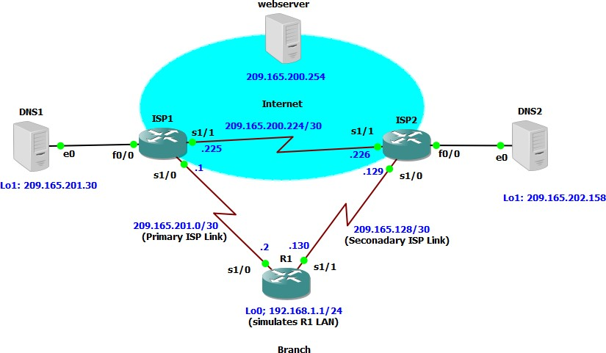

**Objectives:**

* Configure and verify the IP SLA feature.
* Test the IP SLA tracking feature.
* Verify the configuration and operation using **show** and **debug** commands.

## Required Resources

* 3 routers (Cisco IOS Release 15.2 or comparable)
* Serial and Ethernet cables

## Step 1: Prepare the routers and configure the router hostname and interface addresses.

**a. Cable the network as shown in the topology diagram**

**Router R1**

hostname R1

interface Loopback 0

description R1 LAN

ip address 192.168.1.1 255.255.255.0

interface Serial0/0

description R1 --> ISP1

ip address 209.165.201.2 255.255.255.252

clock rate 128000

bandwidth 128

no shutdown

interface Serial0/1

description R1 --> ISP2

ip address 209.165.202.130 255.255.255.252

bandwidth 128

no shutdown

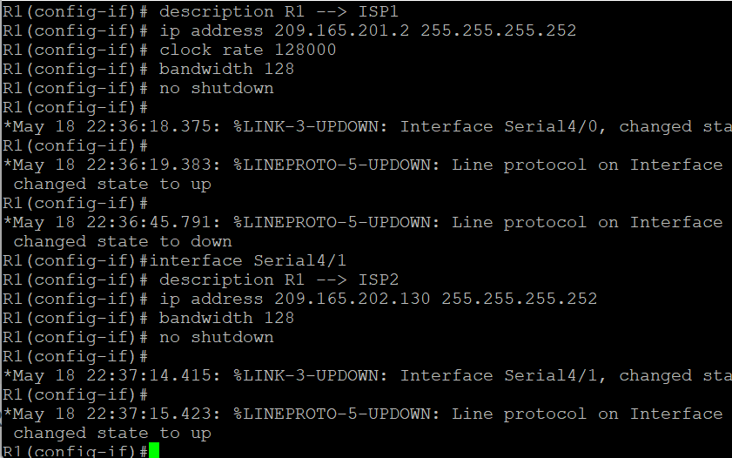

**Router ISP1 (R2)**

hostname ISP1

interface Loopback0

description Simulated Internet Web Server

ip address 209.165.200.254 255.255.255.255

interface Loopback1

description ISP1 DNS Server

ip address 209.165.201.30 255.255.255.255

interface Serial0/0/0

description ISP1 --> R1

ip address 209.165.201.1 255.255.255.252

bandwidth 128

no shutdown

interface Serial0/0/1

description ISP1 --> ISP2

ip address 209.165.200.225 255.255.255.252

clock rate 128000

bandwidth 128

no shutdown

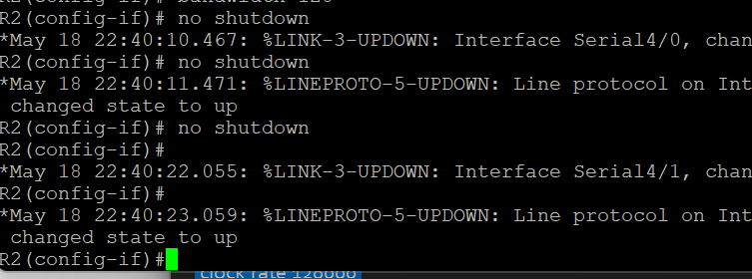

**Router ISP2 (R3)**

hostname ISP2

interface Loopback0

description Simulated Internet Web Server

ip address 209.165.200.254 255.255.255.255

interface Loopback1

description ISP2 DNS Server

ip address 209.165.202.158 255.255.255.255

interface Serial0/0/0

description ISP2 --> R1

ip address 209.165.202.129 255.255.255.252

clock rate 128000

bandwidth 128

no shutdown

interface Serial0/0/1

description ISP2 --> ISP1

ip address 209.165.200.226 255.255.255.252

bandwidth 128

no shutdown

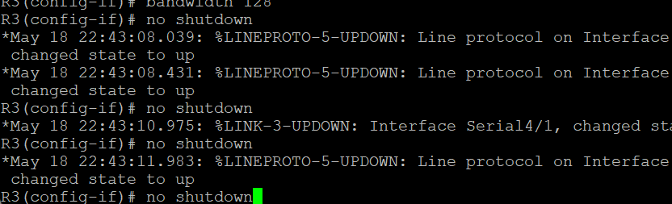

**b.Verify the configuration by using the show interfaces descriptioncommand**.

R1# **show interfaces description | include up**

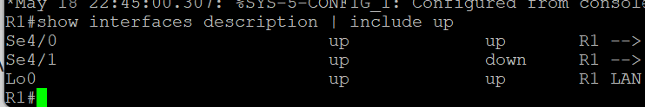

# **Step 2: Configure static routing.**

**a. Implement the routing policies on the respective routers.**

**Router R1**

R1(config)# **ip route 0.0.0.0 0.0.0.0 209.165.201.1**

R1(config)#

**Router ISP1 (R2)**

ISP1(config)# **router eigrp 1**

ISP1(config-router)# **network 209.165.200.224 0.0.0.3**

ISP1(config-router)# **network 209.165.201.0 0.0.0.31**

ISP1(config-router)# **no auto-summary**

ISP1(config-router)# **exit**

ISP1(config)#

ISP1(config-router)# **ip route 192.168.1.0 255.255.255.0 209.165.201.2**

ISP1(config)#

**Router ISP2 (R3)**

ISP2(config)# **router eigrp 1**

ISP2(config-router)# **network 209.165.200.224 0.0.0.3**

ISP2(config-router)# **network 209.165.202.128 0.0.0.31**

ISP2(config-router)# **no auto-summary**

ISP2(config-router)# **exit**

ISP2(config)#

ISP2(config)# **ip route 192.168.1.0 255.255.255.0 209.165.202.130**

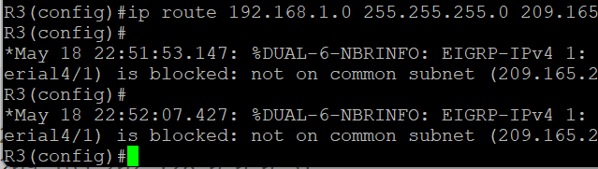

b. **The Cisco IOS IP SLA feature enables an administrator to monitor network performance between Cisco devices (switches or routers) or from a Cisco device to a remote IP device.**

foreach address {

209.165.200.254

209.165.201.30

209.165.202.158

} {

ping $address source 192.168.1.1

}

**c. Trace the path taken to the web server, ISP1 DNS server, and ISP2 DNS server. You can copy the following Tcl script and paste it into R1.**

foreach address {

209.165.200.254

209.165.201.30

209.165.202.158

} {

trace $address source 192.168.1.1

}

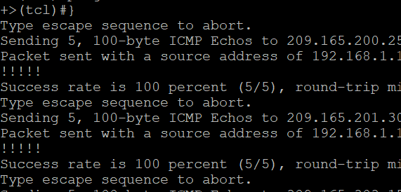

**Step 3: Configure IP SLA probes.**

**a.Create an ICMP echo probe on R1 to the primary DNS server on ISP1 using the ip sla command.**

R1(config)# ip sla 11

R1(config-ip-sla)# icmp-echo 209.165.201.30

R1(config-ip-sla-echo)# frequency 10

R1(config-ip-sla-echo)# exit

R1(config)#

R1(config)# ip sla schedule 11 life forever start-time now

R1(config)#

**b.Verify the IP SLAs configuration of operation 11 using the show ip sla configuration 11command.**

R1# **show ip sla configuration 11**

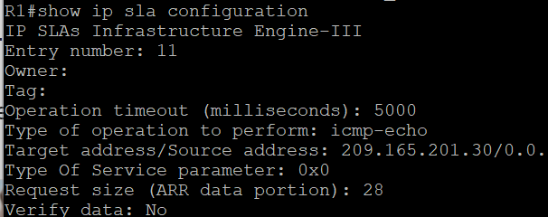

**c. Issue the show ip sla statisticscommand to display the number of successes, failures, and results of the latest operations.**

R1# **show ip sla statistics**

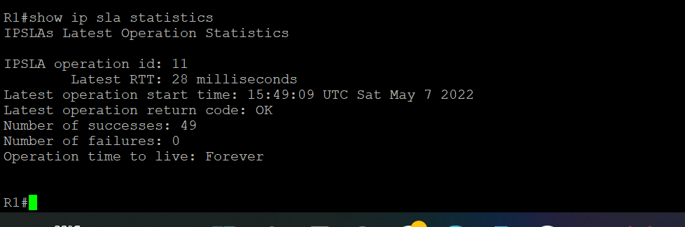

**d. Although not actually required because IP SLA session 11 alone could provide the desired fault tolerance, create a second probe, 22, to test connectivity to the second DNS server located on router ISP2.**

R1(config)# **ip sla 22**

R1(config-ip-sla)# **icmp-echo 209.165.202.158**

R1(config-ip-sla-echo)# **frequency 10**

R1(config-ip-sla-echo)# **exit**

R1(config)#

R1(config)# **ip sla schedule 22 life forever start-time now**

R1(config)# **end**

R1#

**e. Verify the new probe using the show ip sla configuration andshow ip sla statistics commands.**

R1# **show ip sla configuration 22**

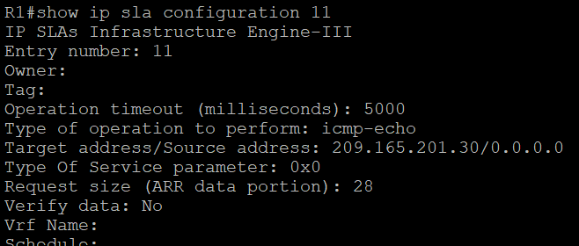

R1#**show ip sla statistics 22**

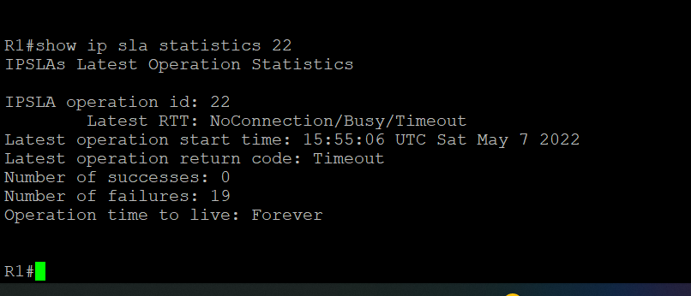

# **Step 4: Configure tracking options.**

**a.On R1, remove the current default route and replace it with a floating static route having an administrative distance of 5.**

R1(config)# **no ip route 0.0.0.0 0.0.0.0 209.165.201.1**

R1(config)# **ip route 0.0.0.0 0.0.0.0 209.165.201.1 5**

R1(config)# **exit**

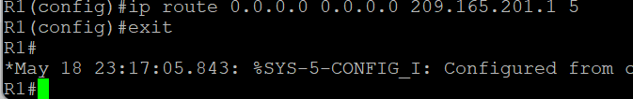

**b.Verify the routing table.**

R1# **show ip route | begin Gateway**

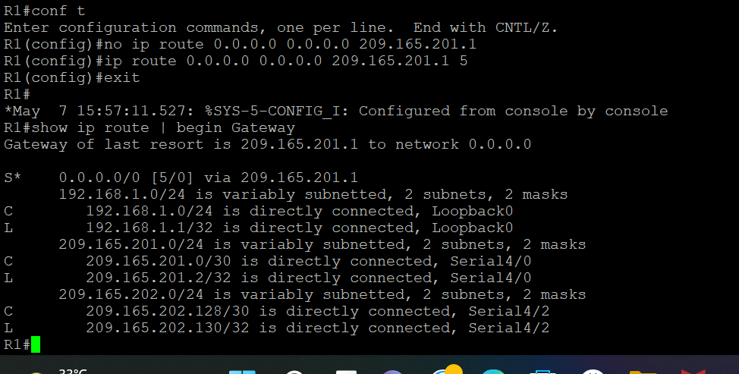

**C .From global configuration mode on R1, use the track 1 ip sla 11 reachabilitycommand to enter the config-track subconfiguration mode.**

R1(config)# **track 1 ip sla 11 reachability**

R1(config-track)#

**d. Specify the level of sensitivity to changes of tracked objects to 10 seconds of down delay and 1 second of up delay using the delay down 10 u1 command.**

R1(config-track)# **delay down 10 up 1**

R1(config-track)# **exit**

R1(config)#

**e. To view routing table changes as they happen, first enable the debug ip routing command**.

R1# **debug ip routing**

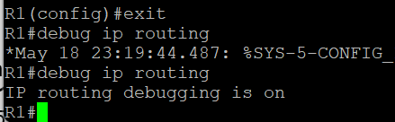

**f. Configure the floating static route that will be implemented when tracking object 1 is active.**

R1(config)# **ip route 0.0.0.0 0.0.0.0 209.165.201.1 2 track 1**

R1(config)#

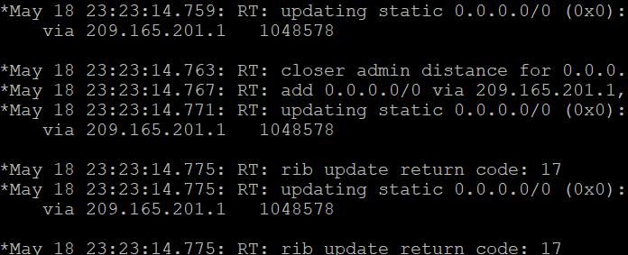

**g.Repeat the steps for operation 22, track number 2, and assign the static route an admin distance higher than track 1 and lower than 5.**

R1(config)# **track 2 ip sla 22 reachability**

R1(config-track)# **delay down 10 up 1**

R1(config-track)# **exit**

R1(config)#

R1(config)# **ip route 0.0.0.0 0.0.0.0 209.165.202.129 3 track 2**

R1(config)#

**h. Verify the routing table again.**

R1#show ip route | begin Gateway

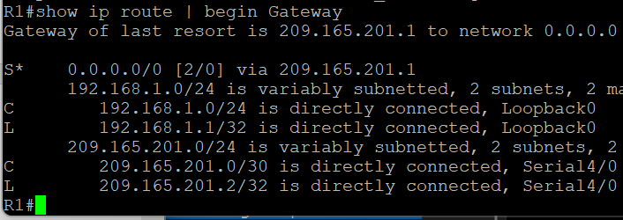

# **Step 5: Verify ip sla operation.**

**a.On ISP1, disable the loopback interface 1.**

ISP1(config-if)# **int lo1**

ISP1(config-if)# **shutdown**

ISP1(config-if)#

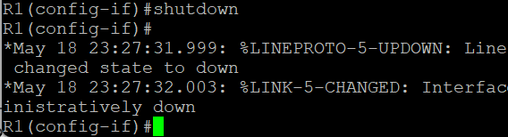

**b.On R1, observe the debug output being generated**.

R1# **show ip route | begin Gateway**

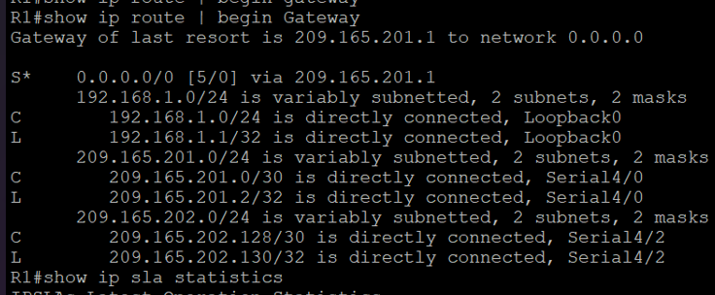

**c.Verify the IP SLA statistics.**

R1# **show ip sla statistics**

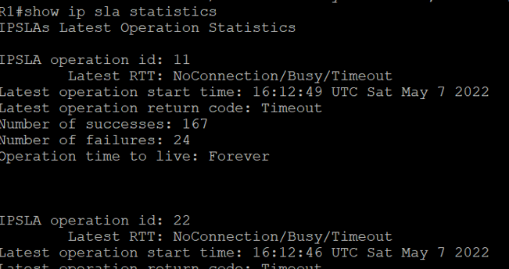

**d. On R1, initiate a trace to the web server from the internal LAN IP address.**

R1# **trace 209.165.200.254 source 192.168.1.1**

**e. On ISP1, re-enable the DNS address by issuing the no shutdowncommand on the loopback 1 interface**

ISP1(config-if)# **no shutdown**

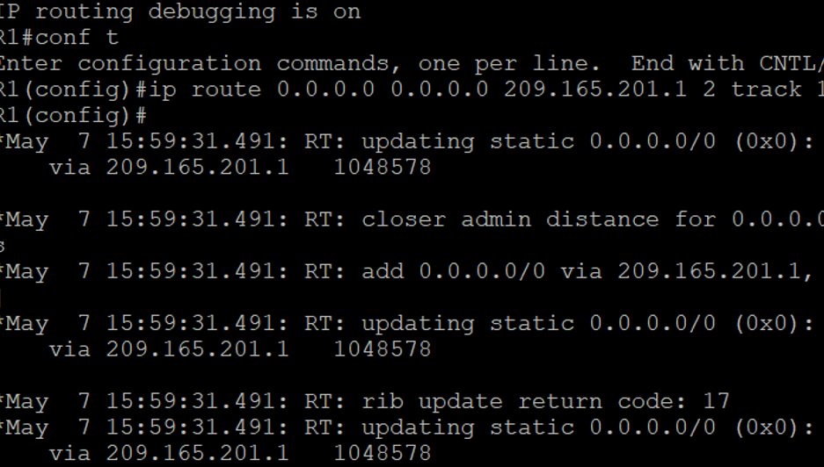.

**f. Again examine the IP SLA statistics.**

R1# **show ip sla statistics**

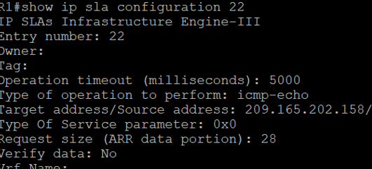.

**g.Verify the routing table**.

R1# **show ip route | begin Gateway**



**Practical No – 2**

**Aim:** Using the AS_PATH Attribute.

**Topolgy :**

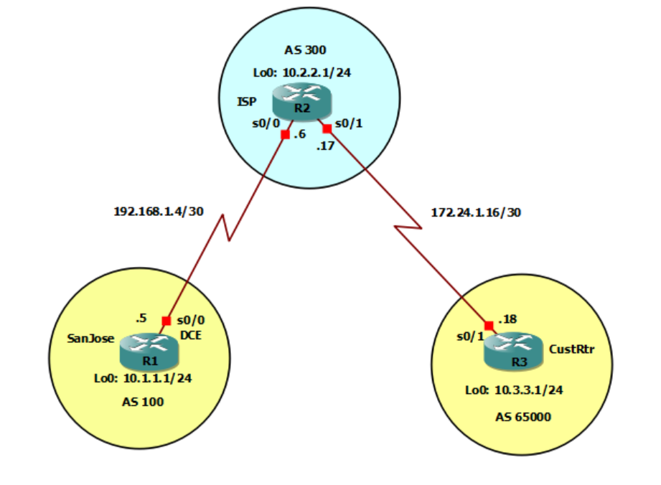

**Objectives:**

* Use BGP commands to prevent private AS numbers from being advertised to the outside world.
* Use the AS_PATH attribute to filter BGP routes based on their source AS numbers.

## Required Resources

* 3 routers (Cisco IOS Release 15.2 or comparable)
* Serial and Ethernet cables

**Step 0: Prepare the routers for the lab.**

**a.Apply the following configuration to each router along with the appropriate hostname. The exec-timeout 0 0 command should only be used in a lab environment**

Router(config)# no ip domain-lookup

Router(config)# line con 0

Router(config-line)# logging synchronous

Router(config-line)# exec-timeout 0 0

**Step 2 : Configure the hostname and interface addresses**.

**a.You can copy and paste the following configurations into your routers to begin.**

SanJose(config)# interface Loopback0

SanJose(config-if)# ip address 10.1.1.1 255.255.255.0

SanJose(config-if)# exit

SanJose(config)# interface Serial0/0/0

SanJose(config-if)# ip address 192.168.1.5 255.255.255.252

SanJose(config-if)# clock rate 128000

SanJose(config-if)# no shutdown

SanJose(config-if)# end

SanJose#

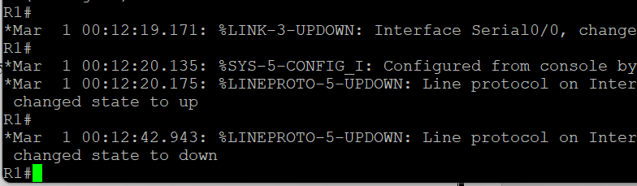

ISP(config)# interface Loopback0

ISP(config-if)# ip address 10.2.2.1 255.255.255.0

ISP(config-if)# interface Serial0/0/0

ISP(config-if)# ip address 192.168.1.6 255.255.255.252

ISP(config-if)# no shutdown

ISP(config-if)# exit

ISP(config)# interface Serial0/0/1

ISP(config-if)# ip address 172.24.1.17 255.255.255.252

ISP(config-if)# clock rate 128000

ISP(config-if)# no shutdown

ISP(config-if)# end

ISP#

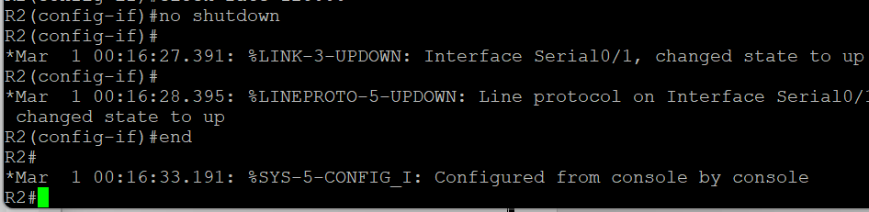

CustRtr(config)# interface Loopback0

CustRtr(config-if)# ip address 10.3.3.1 255.255.255.0

CustRtr(config-if)# exit

CustRtr(config)# interface Serial0/0/1

CustRtr(config-if)# ip address 172.24.1.18 255.255.255.252

CustRtr(config-if)# no shutdown

CustRtr(config-if)# end

CustRtr#

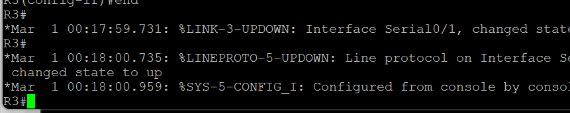

**b. Use ping to test the connectivity between the directly connected routers.**

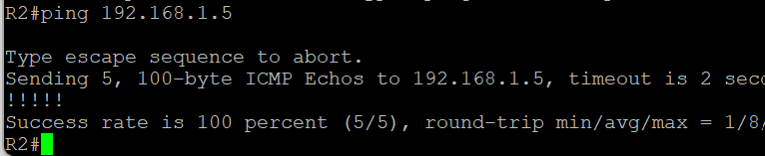

### **Step 3 : Configure BGP.**

1. **Configure BGP for normal operation. Enter the appropriate BGP commands on each router so that they identify their BGP neighbors and advertise their loopback networks.**

SanJose#show ip route

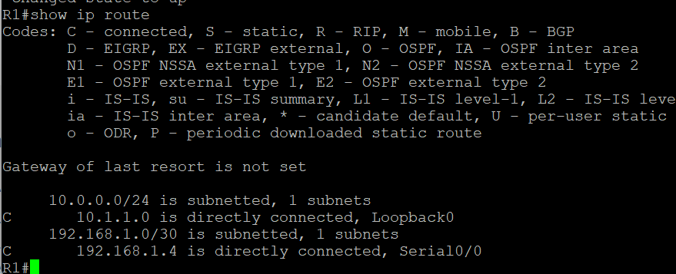

1. **Ping the 10.3.3.1 address from SanJose.**

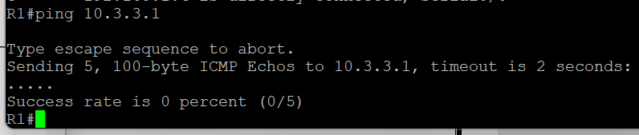

1. **Ping again, this time as an extended ping, sourcing from the Loopback0 interface address.**

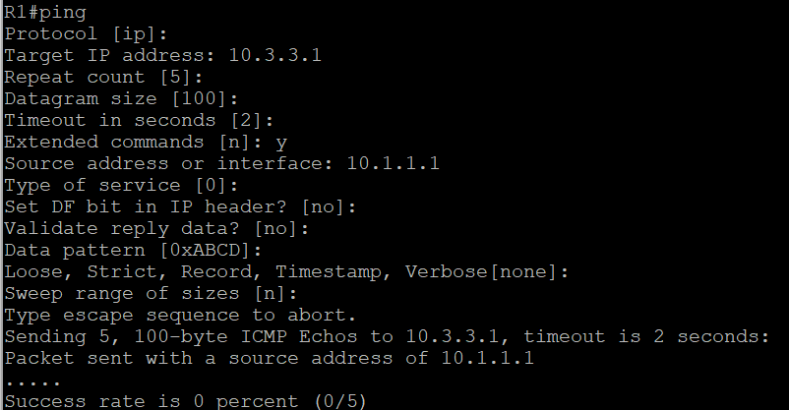

**SanJose# ping 10.3.3.1 source 10.1.1.1**

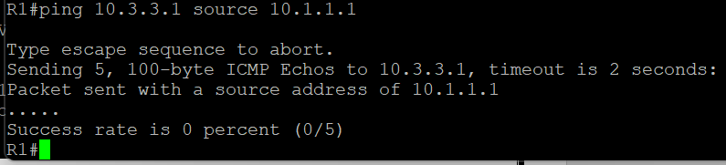

1. **Check the BGP table from SanJose by using the show ip bgp command.**

SanJose# show ip bgp

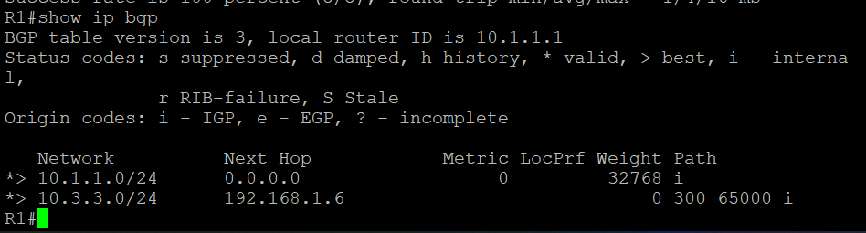

1. **Configure ISP to strip the private AS numbers from BGP routes exchanged with SanJose using the following commands**.

ISP(config)# router bgp 300

ISP(config-router)# neighbor 192.168.1.5 remove-private-as

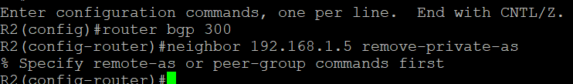

1. **After issuing these commands, use the clear ip bgp * command on ISP to reestablish the BGP relationship between the three routers.**

ISP# clear ip bgp *

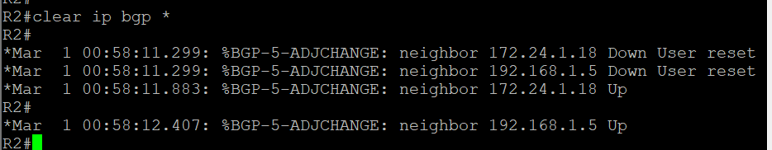

SanJose# show ip route

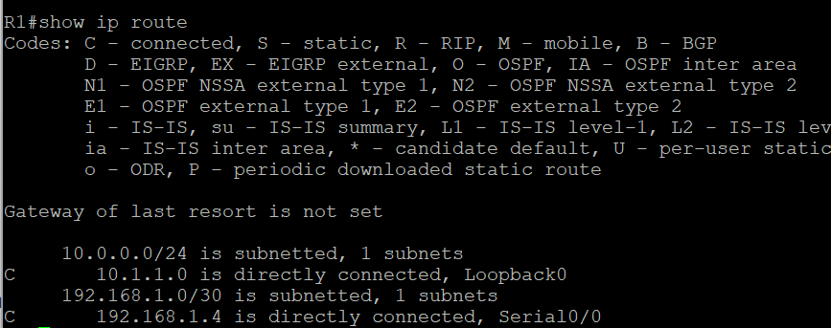

SanJose# ping 10.3.3.1 source lo0

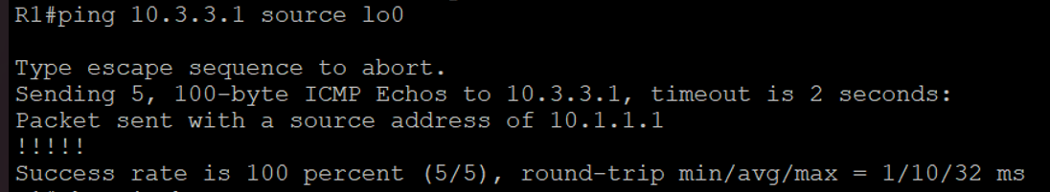

1. **Now check the BGP table on SanJose. The AS_ PATH to the 10.3.3.0 network should be AS 300. It no longer has the private AS in the path.**

SanJose# show ip bgp

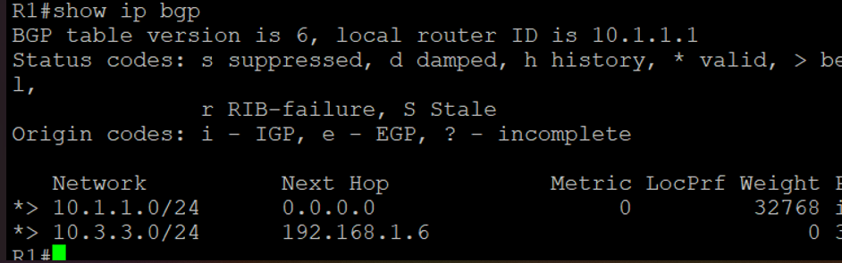

### **Step 4 : Remove the private AS.**

**a. Configure a special kind of access list to match BGP routes with an AS_PATH attribute that both begins and ends with the number 100.**

ISP(config)# ip as-path access-list 1 deny ^100$

ISP(config)# ip as-path access-list 1 permit .*

ISP(config)# router bgp 300

ISP(config-router)# neighbor 172.24.1.18 filter-list 1 out

**b. Use the clear ip bgp * command to reset the routing information.**

ISP# clear ip bgp *

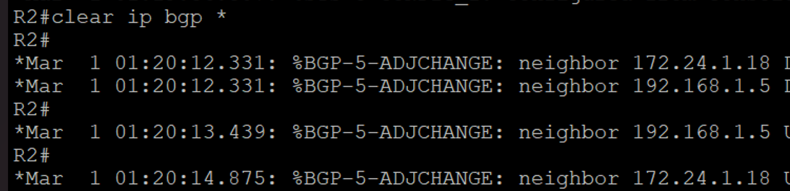

ISP# show ip route

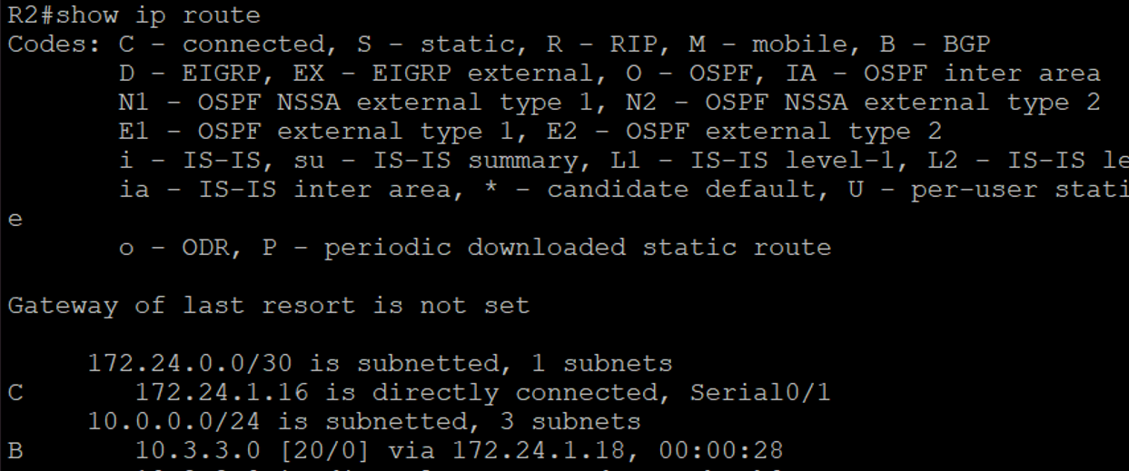

**c. Check the routing table for CustRtr. It should not have a route to 10.1.1.0 in its routing table.**

CustRtr# show ip route

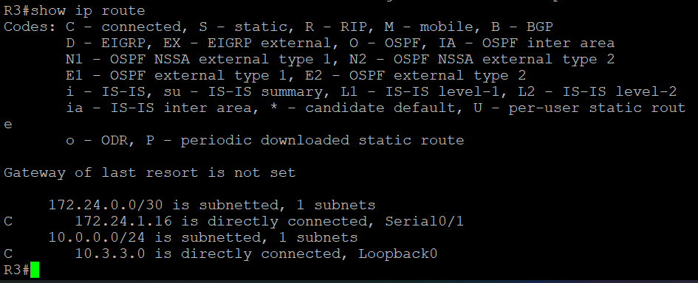

**e. Return to ISP and verify that the filter is working as intended. Issue the show ip bgp regexp ^100$ command.**

ISP# show ip bgp regexp ^100$

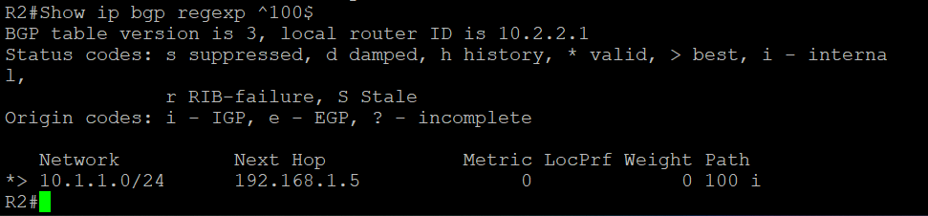

**f. Run the following Tcl script on all routers to verify whether there is connectivity.**

**ISP# tclsh**

foreach address {

10.1.1.1

10.2.2.1

10.3.3.1

192.168.1.5

192.168.1.6

172.24.1.17

172.24.1.18

} {

ping $address }

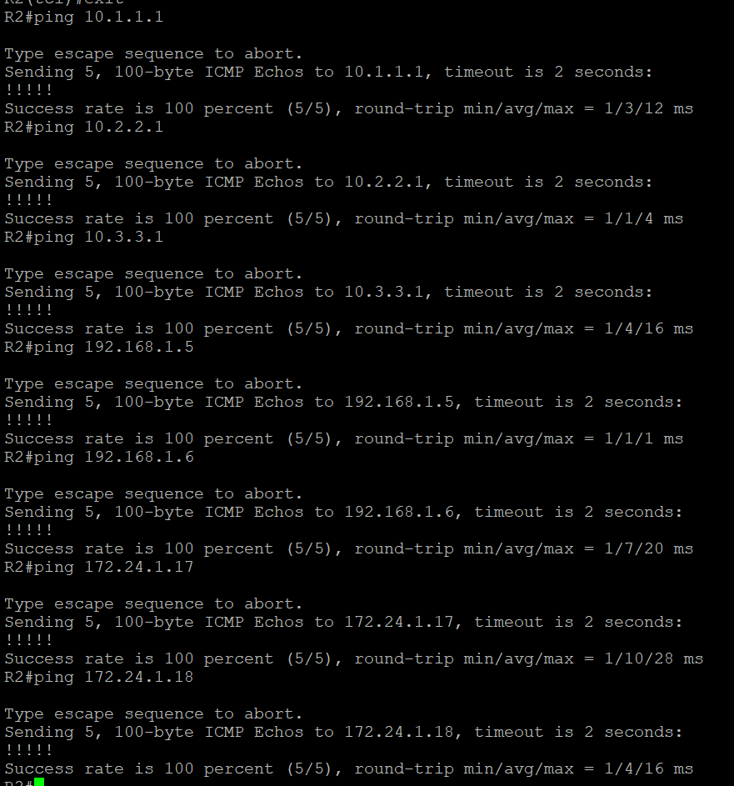

**Practical No – 3**

**Aim:** Configuring IBGP and EBGP Sessions, Local Preference, and MED

**Topolgy :**

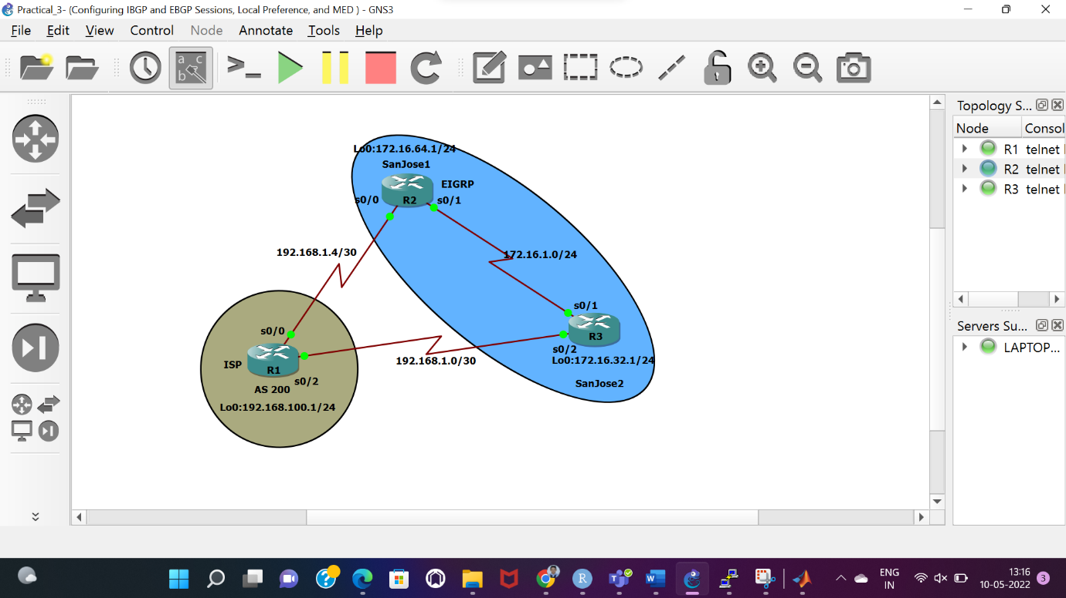

**Objectives:**

* For IBGP peers to correctly exchange routing information, use the **next-hop-self** command with the **Local-Preference** and **MED** attributes.
* Ensure that the flat-rate, unlimited-use T1 link is used for sending and receiving data to and from the AS 200 on ISP and that the metered T1 only be used in the event that the primary T1 link has failed.

## Required Resources

* 3 routers (Cisco IOS Release 15.2 or comparable)
* Serial and Ethernet cables

### **Step 0: Suggested starting configurations.**

**a. Apply the following configuration to each router along with the appropriate hostname.**

Router(config)# no ip domain-lookup

Router(config)# line con 0

Router(config-line)# logging synchronous

Router(config-line)# exec-timeout 0 0

### **Step 1: Configure interface addresses.**

**a. Using the addressing scheme in the diagram, create the loopback interfaces and apply IPv4 addresses to these and the serial interfaces on ISP (R1), SanJose1 (R2), and SanJose2 (R3)**

**Router R1 (hostname ISP)**

ISP(config)# interface Loopback0

ISP(config-if)# ip address 192.168.100.1 255.255.255.0

ISP(config-if)# exit

ISP(config)# interface Serial0/0/0

ISP(config-if)# ip address 192.168.1.5 255.255.255.252

ISP(config-if)# clock rate 128000

ISP(config-if)# no shutdown

ISP(config-if)# exit

ISP(config)# interface Serial0/0/1

ISP(config-if)# ip address 192.168.1.1 255.255.255.252

ISP(config-if)# no shutdown

ISP(config-if)# end

ISP#

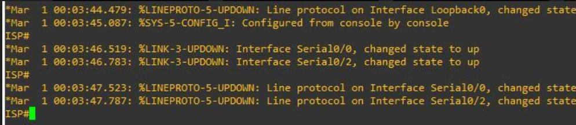

**Router R2 (hostname SanJose1)**

SanJose1(config)# interface Loopback0

SanJose1(config-if)# ip address 172.16.64.1 255.255.255.0

SanJose1(config-if)# exit

SanJose1(config)# interface Serial0/0/0

SanJose1(config-if)# ip address 192.168.1.6 255.255.255.252

SanJose1(config-if)# no shutdown

SanJose1(config-if)# exit

SanJose1(config)# interface Serial0/0/1

SanJose1(config-if)# ip address 172.16.1.1 255.255.255.0

SanJose1(config-if)# clock rate 128000

SanJose1(config-if)# no shutdown

SanJose1(config-if)# end

SanJose1#

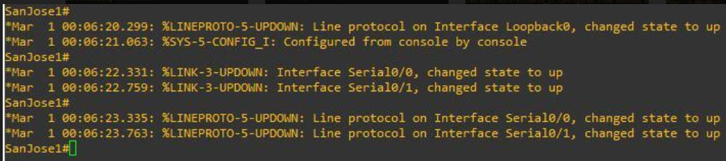

**Router R3 (hostname SanJose2)**

SanJose2(config)# interface Loopback0

SanJose2(config-if)# ip address 172.16.32.1 255.255.255.0

SanJose2(config-if)# exit

SanJose2(config)# interface Serial0/0/0

SanJose2(config-if)# ip address 192.168.1.2 255.255.255.252

SanJose2(config-if)# clock rate 128000

SanJose2(config-if)# no shutdown

SanJose2(config-if)# exit

SanJose2(config)# interface Serial0/0/1

SanJose2(config-if)# ip address 172.16.1.2 255.255.255.0

SanJose2(config-if)# no shutdown

SanJose2(config-if)# end

SanJose2#

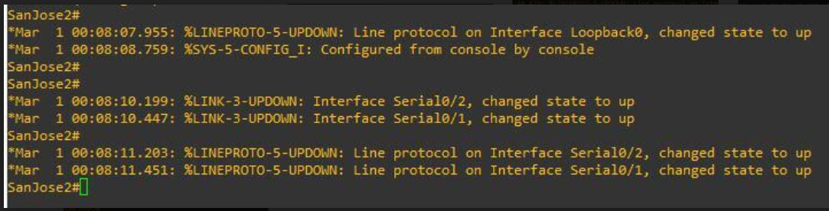

**b. Use ping to test the connectivity between the directly connected routers. Both SanJose routers should be able to ping each other and their local ISP serial link IP address.**

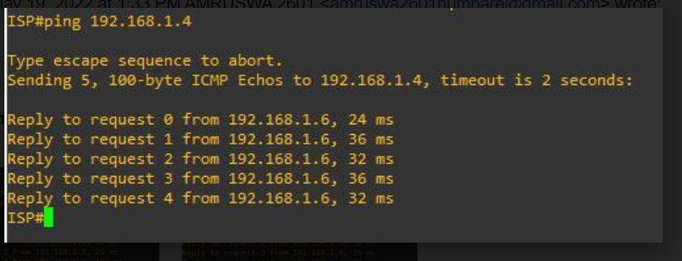

### **Step 2: Configure EIGRP.**

**Configure EIGRP between the SanJose1 and SanJose2 routers.**

SanJose1(config)# router eigrp 1

SanJose1(config-router)# network 172.16.0.0

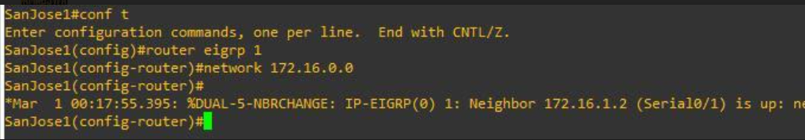

SanJose2(config)# router eigrp 1

SanJose2(config-router)# network 172.16.0.0

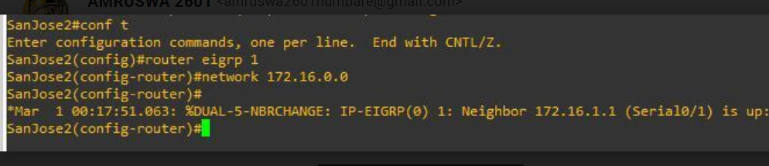

### **Step 3: Configure IBGP and verify BGP neighbors.**

**a. Configure IBGP between the SanJose1 and SanJose2 routers. On the SanJose1 router, enter the following configuration.**

SanJose1(config)# router bgp 64512

SanJose1(config-router)# neighbor 172.16.32.1 remote-as 64512

SanJose1(config-router)# neighbor 172.16.32.1 update-source lo0

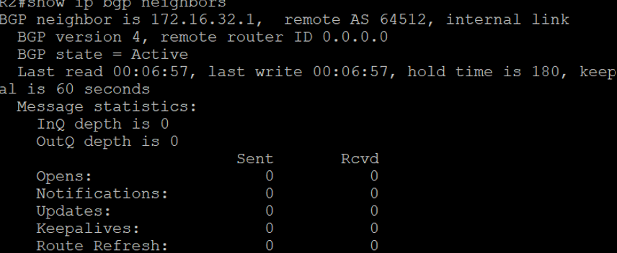

**b. Complete the IBGP configuration on SanJose2 using the following commands.**

SanJose2(config)# router bgp 64512

SanJose2(config-router)# neighbor 172.16.64.1 remote-as 64512

SanJose2(config-router)# neighbor 172.16.64.1 update-source lo0

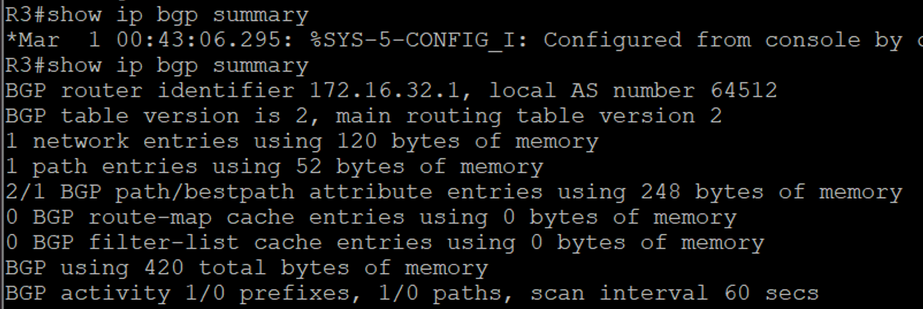

**c. Verify that SanJose1 and SanJose2 become BGP neighbors by issuing the show ip bgp neighbors command on SanJose1.**

SanJose2# show ip bgp neighbors

BGP neighbor is 172.16.64.1, remote AS 64512, internal link

BGP version 4, remote router ID 172.16.64.1

BGP state = Established, up for 00:00:22

Last read 00:00:22, last write 00:00:22, hold time is 180, keepalive interval is 60 seconds

<output omitted>

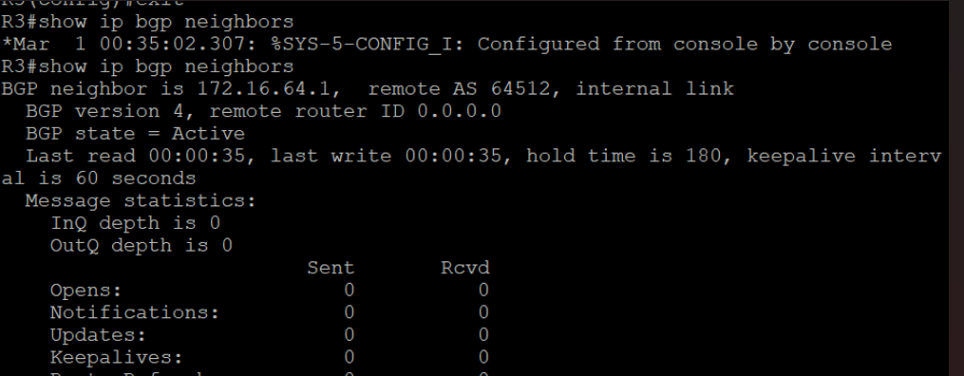

### **Step 4: Configure EBGP and verify BGP neighbors.**

**a. Configure ISP to run EBGP with SanJose1 and SanJose2. Enter the following commands on ISP.**

ISP(config)# router bgp 200

ISP(config-router)# neighbor 192.168.1.6 remote-as 64512

ISP(config-router)# neighbor 192.168.1.2 remote-as 64512

ISP(config-router)# network 192.168.100.0

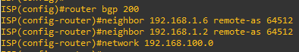

SanJose1(config)# ip route 172.16.0.0 255.255.0.0 null0

**c. Configure SanJose1 as an EBGP peer to ISP**

SanJose1(config)# router bgp 64512

SanJose1(config-router)# neighbor 192.168.1.5 remote-as 200

SanJose1(config-router)# network 172.16.0.0

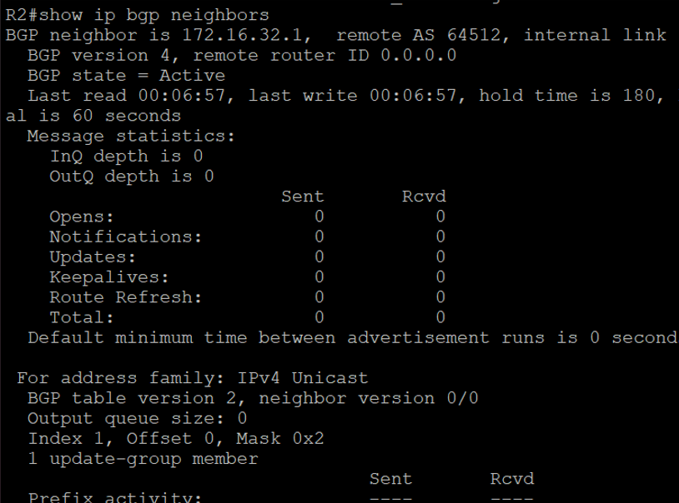

**d. Use the show ip bgp neighbors command to verify that SanJose1 and ISP have reached the established state.**

SanJose1# show ip bgp neighbors

BGP neighbor is 172.16.32.1, remote AS 64512, internal link

BGP version 4, remote router ID 172.16.32.1

BGP state = Established, up for 00:12:43

<output omitted>

BGP neighbor is 192.168.1.5, remote AS 200, external link

BGP version 4, remote router ID 192.168.100.1

BGP state = Established, up for 00:06:49

Last read 00:00:42, last write 00:00:45, hold time is 180, keepalive interval is 60 seconds

<output omitted>

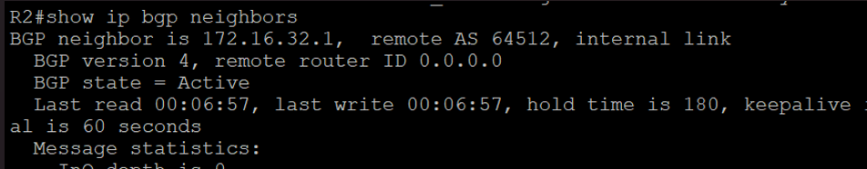

**e. Configure a discard static route for 172.16.0.0/16 on SanJose2 and as an EBGP peer to ISP.**

SanJose2(config)# ip route 172.16.0.0 255.255.0.0 null0

SanJose2(config)# router bgp 64512

SanJose2(config-router)# neighbor 192.168.1.1 remote-as 200

SanJose2(config-router)# network 172.16.0.0

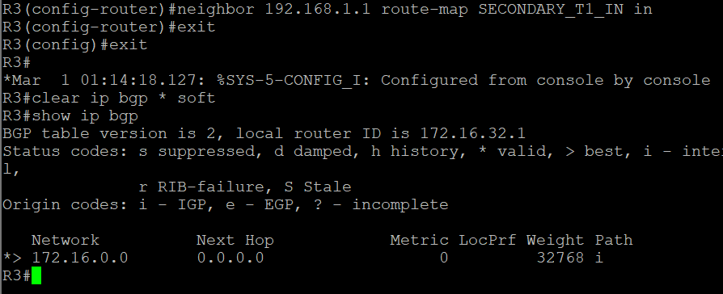

### **Step 5: View BGP summary output.**

**SanJose2# show ip bgp summary**

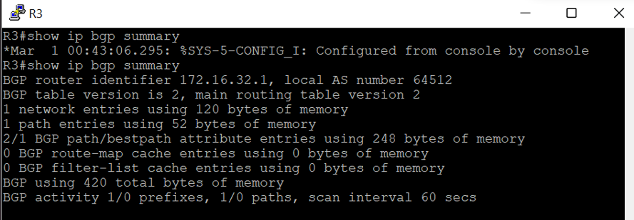

### **Step 6: Verify which path the traffic takes.**

**f. Clear the IP BGP conversation with the clear ip bgp * command on ISP. Wait for the conversations to reestablish with each SanJose router.**

ISP# clear ip bgp *

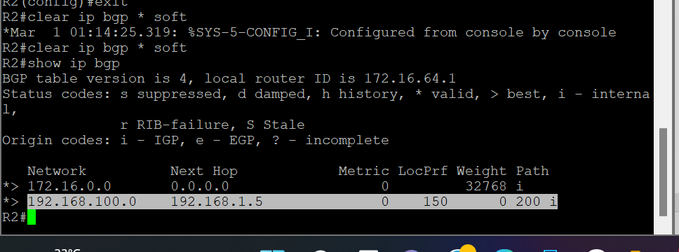

**g. Test whether ISP can ping the loopback 0 address of 172.16.64.1 on SanJose1 and the serial link between SanJose1 and SanJose2, 172.16.1.1.**

ISP# ping 172.16.64.1

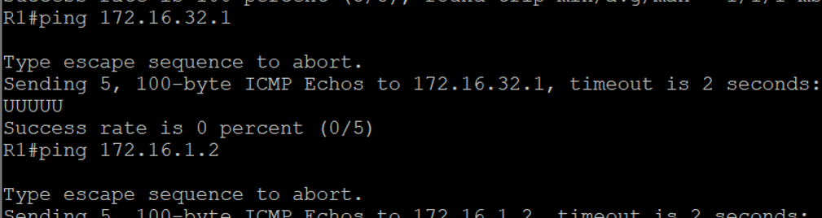

1. **Now ping from ISP to the loopback 0 address of 172.16.32.1 on SanJose2 and the serial link between SanJose1 and SanJose2, 172.16.1.2.**

ISP# ping 172.16.32.1

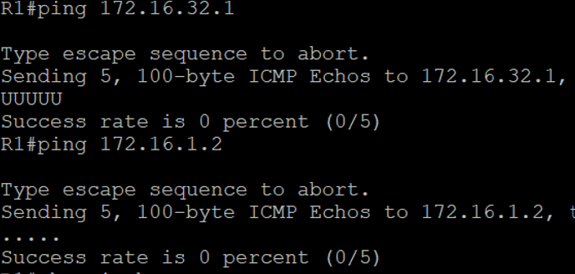

**i. Issue the show ip bgp command on ISP to verify BGP routes and metrics.**

ISP# show ip bgp

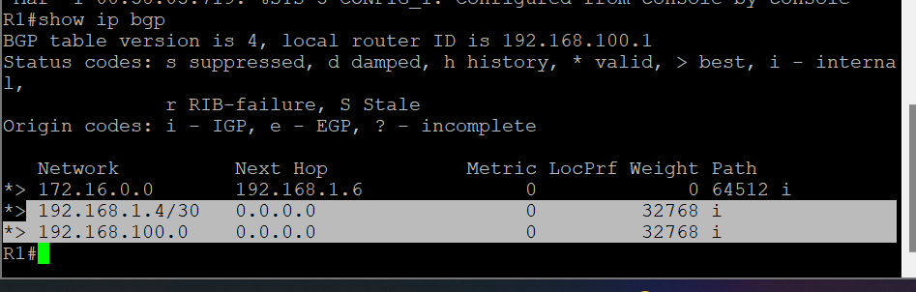

ISP# ping 172.16.1.1 source 192.168.100.1

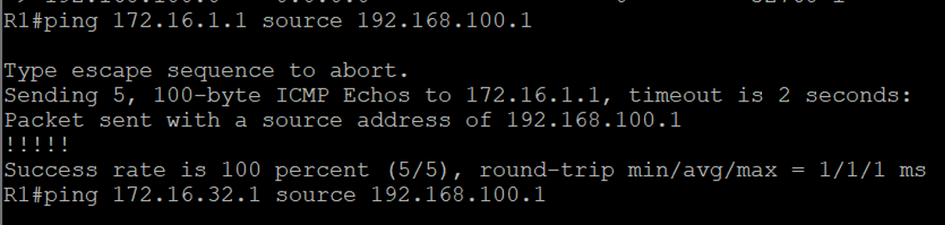

ISP# ping 172.16.64.1 source 192.168.100.1

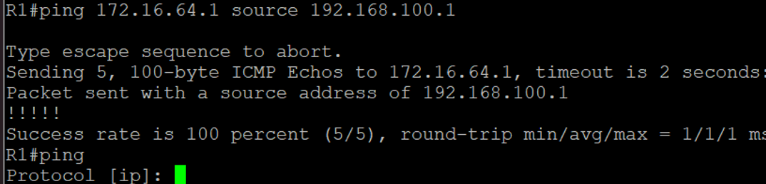

ISP# ping

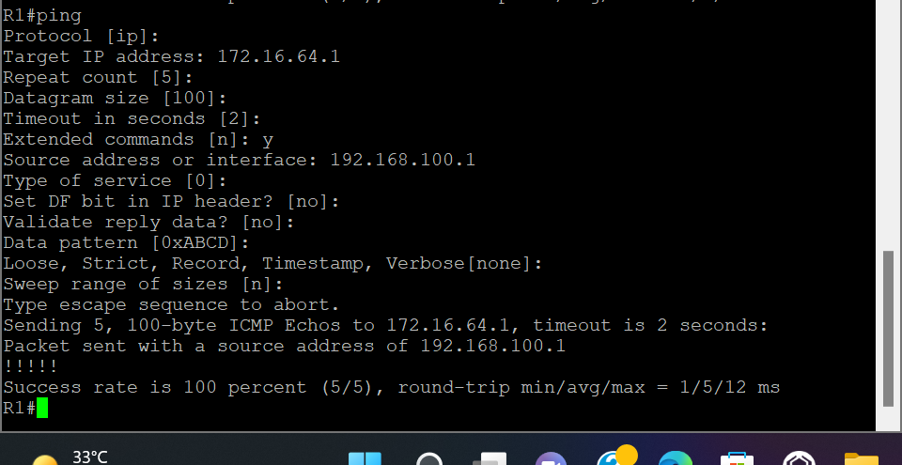

### **Step 7: Configure the BGP next-hop-self feature.**

**a. Issue the following commands on the ISP router.**

ISP(config)# router bgp 200

ISP(config-router)# network 192.168.1.0 mask 255.255.255.252

ISP(config-router)# network 192.168.1.4 mask 255.255.255.252

**b. Issue the show ip bgp command to verify that the ISP is correctly injecting its own WAN links into BGP.**

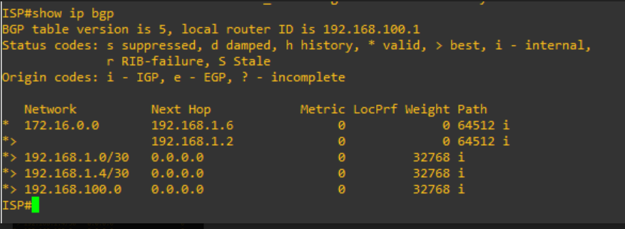

**c. Verify on SanJose1 and SanJose2 that the opposite WAN link is included in the routing table. The output from SanJose2 is as follows.**

SanJose2# show ip route

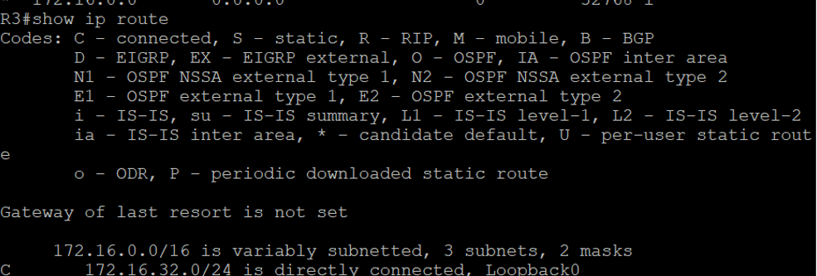

**d. To better understand the next-hop-self command we will remove ISP advertising its two WAN links and shutdown the WAN link between ISP and SanJose2.**

ISP(config)# router bgp 200

ISP(config-router)# no network 192.168.1.0 mask 255.255.255.252

ISP(config-router)# no network 192.168.1.4 mask 255.255.255.252

ISP(config-router)# exit

ISP(config)# interface serial 0/0/1

ISP(config-if)# shutdown

ISP(config-if)#

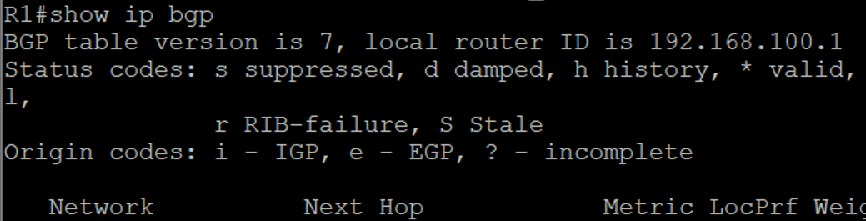

**e. Display SanJose2’s BGP table using the show ip bgp command and the IPv4 routing table with show ip route.**

SanJose2# show ip bgp

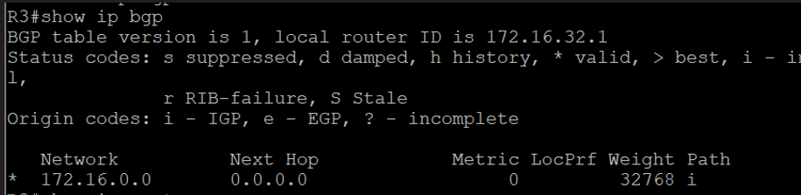

SanJose2# show ip route

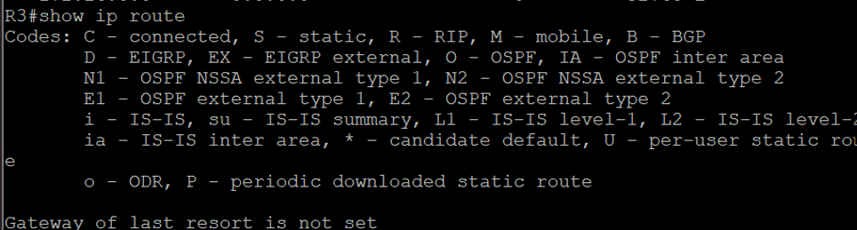

**f. Issue the next-hop-self command on SanJose1 and SanJose2 to advertise themselves as the next hop to their IBGP peer.**

SanJose1(config)# router bgp 64512

SanJose1(config-router)# neighbor 172.16.32.1 next-hop-self

SanJose2(config)# router bgp 64512

SanJose2(config-router)# neighbor 172.16.64.1 next-hop-self

**g. Reset BGP operation on either router with the clear ip bgp * command**

SanJose1# clear ip bgp *

SanJose1#

SanJose2# clear ip bgp *

SanJose2#

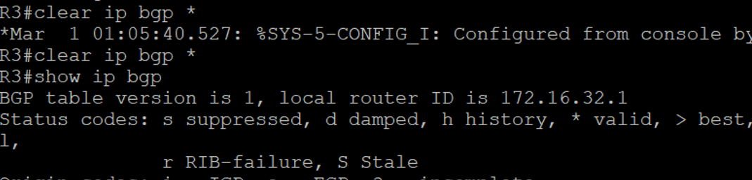

**h. After the routers have returned to established BGP speakers, issue the show ip bgp command on SanJose2 and notice that the next hop is now SanJose1 instead of ISP**

SanJose2# show ip bgp

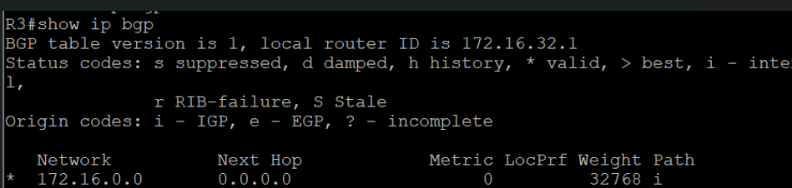

**i. The show ip route command on SanJose2 now displays the 192.168.100.0/24 network because SanJose1 is the next hop, 172.16.64.1, which is reachable from SanJose2.**

SanJose2# show ip route

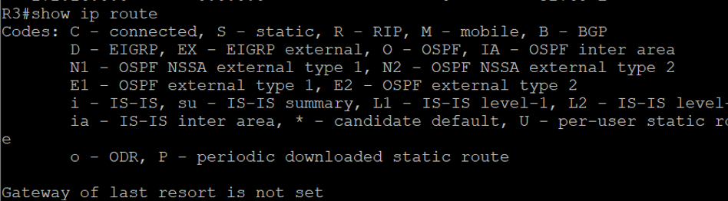

**j. Before configuring the next BGP attribute, restore the WAN link between ISP and SanJose3.**

ISP(config)# interface serial 0/0/1

ISP(config-if)# no shutdown

ISP(config-if)#

SanJose2# show ip route

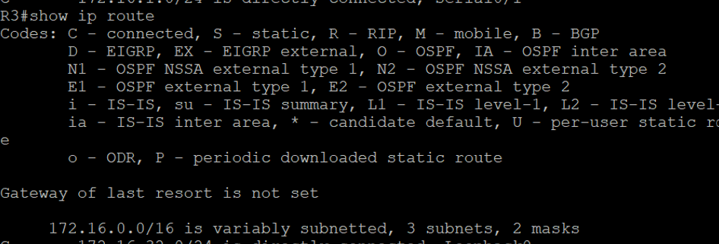

### **Step 8: Set BGP local preference.**

**a. Use the clear ip bgp * soft command after configuring this new policy.**

SanJose1# clear ip bgp * soft



SanJose2# clear ip bgp * soft

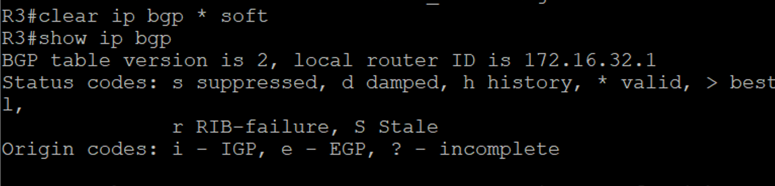

SanJose1# show ip bgp

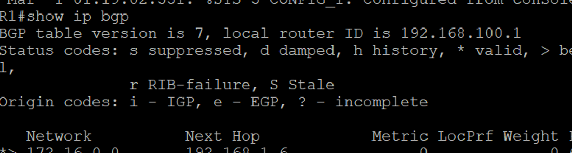

### **Step 9: Set BGP MED.**

**a. In the previous step we saw that SanJose1 and SanJose2 will route traffic for 192.168.100.0/24 using the link between SanJose1 and ISP.**

ISP# show ip bgp

ISP# show ip route

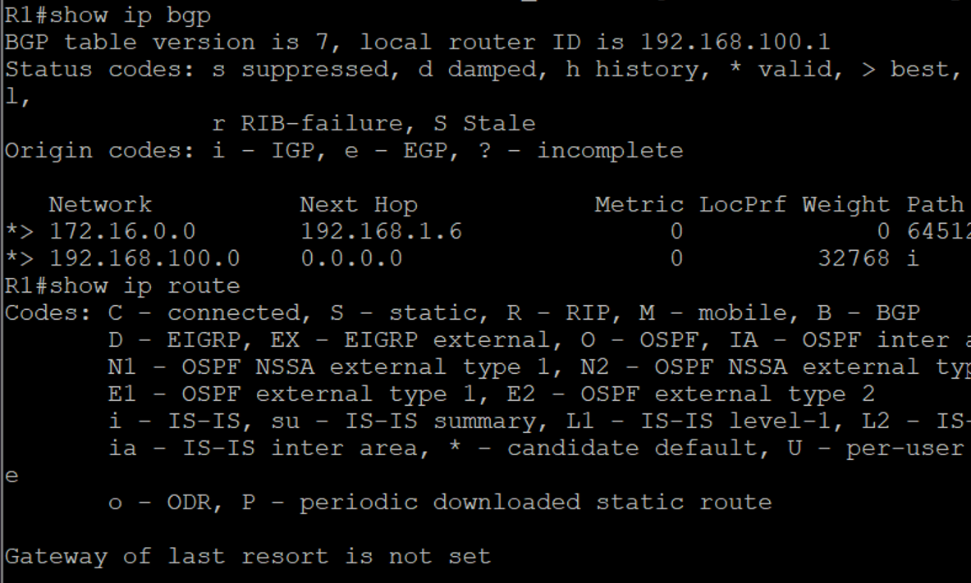

**b. Use an extended ping command to verify this situation.**

SanJose2# ping

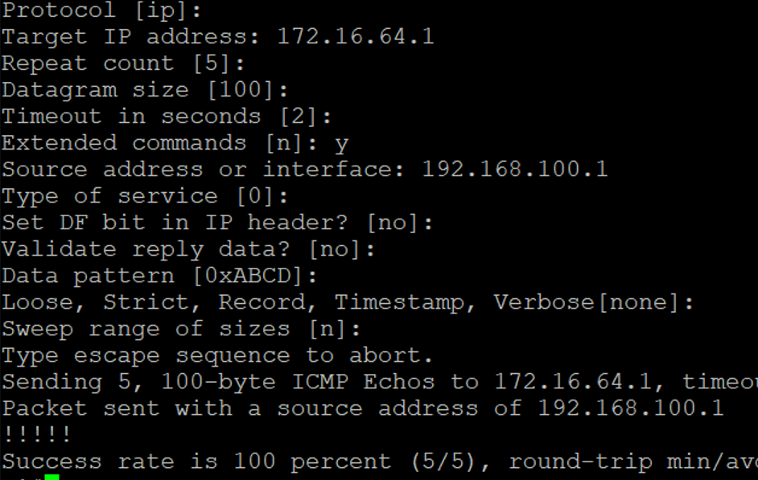

**c. Use the clear ip bgp * soft command after issuing this new policy.**

SanJose1# clear ip bgp * soft



SanJose2# clear ip bgp * soft

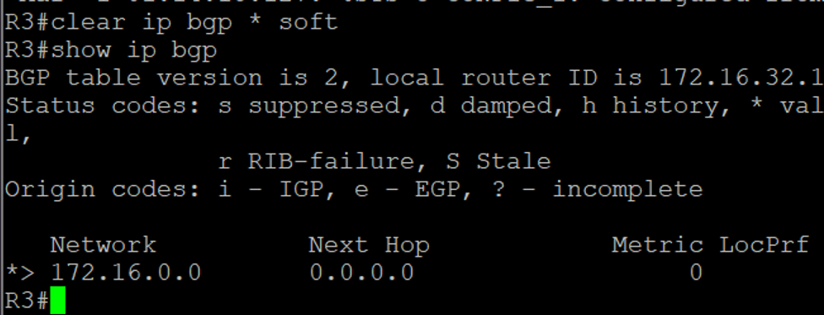

**d. Reissue an extended ping command with the record command.**

SanJose2# ping

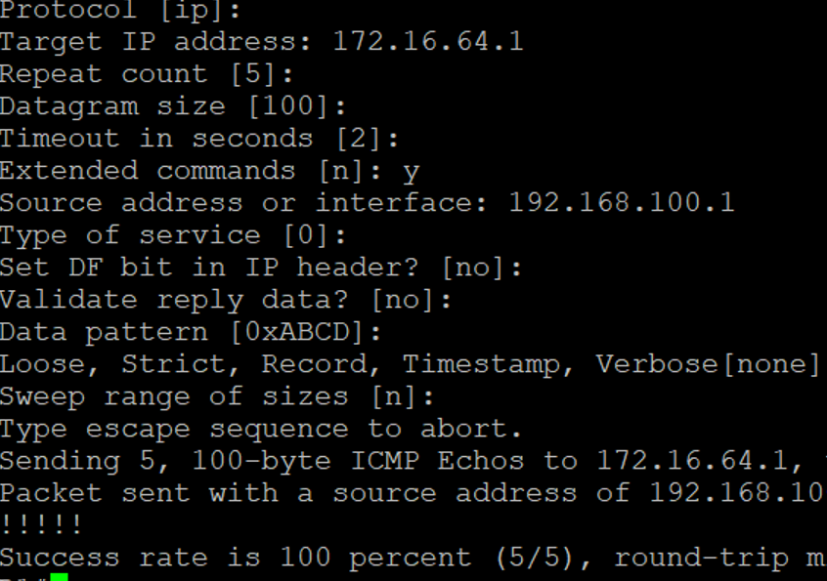

ISP# show ip bgp



### **Step 10: Establish a default route.**

**a. Configure ISP to inject a default route to both SanJose1 and SanJose2 using BGP using the default-originate command**

ISP(config)# router bgp 200

ISP(config-router)# neighbor 192.168.1.6 default-originate

ISP(config-router)# neighbor 192.168.1.2 default-originate

ISP(config-router)# exit

ISP(config)# interface loopback 10

ISP(config-if)# ip address 10.0.0.1 255.255.255.0

ISP(config-if)#

**b. Verify that both routers have received the default route by examining the routing tables on SanJose1 and SanJose2.**

SanJose1# show ip route

SanJose2# show ip bgp

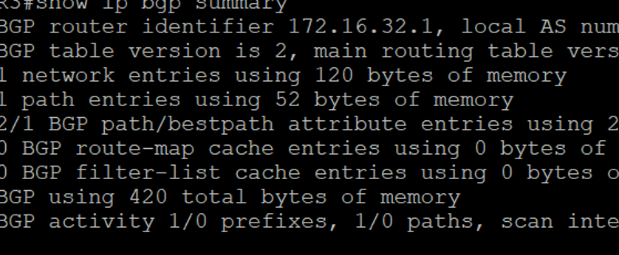

SanJose2# traceroute 10.0.0.1

SanJose1# trace 10.0.0.1

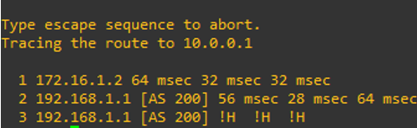

**Practical No – 4**

**Aim:** Secure the Management Plane

**Topolgy :**

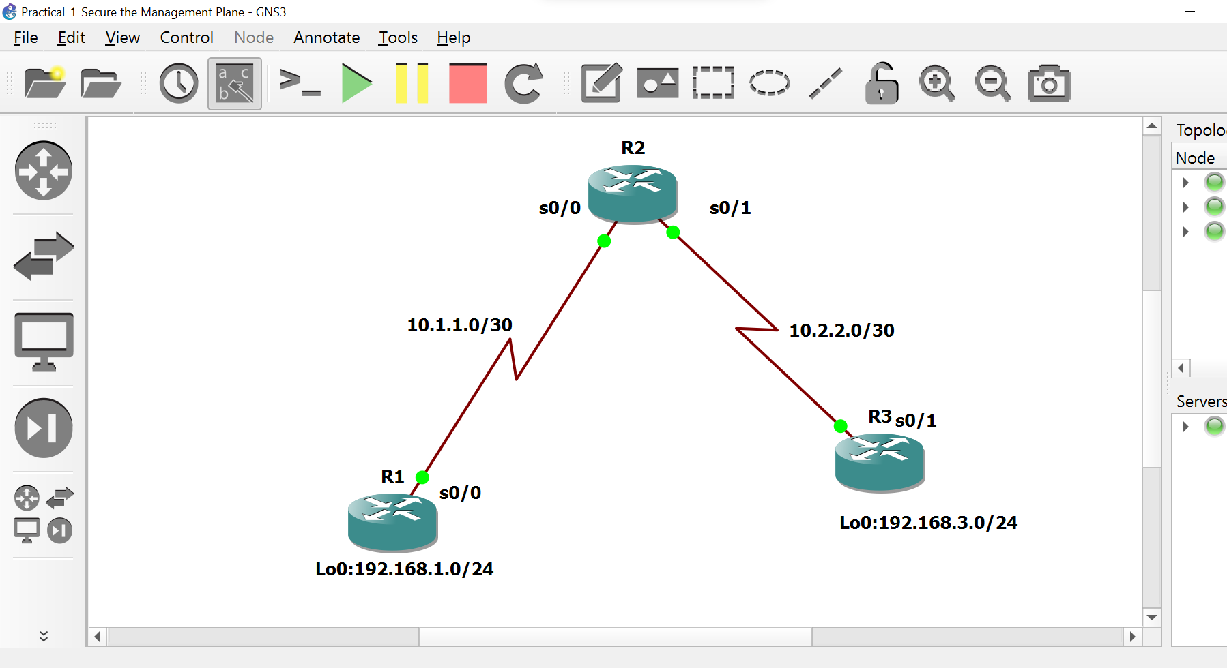

### **Objectives**

* Secure management access.
* Configure enhanced username password security.
* Enable AAA RADIUS authentication.
* Enable secure remote management.

### **Required Resources**

* 3 routers (Cisco IOS Release 15.2 or comparable)
* Serial and Ethernet cables

### **Step 1: Configure loopbacks and assign addresses.**

**a. Cable the network as shown in the topology diagram. Erase the startup configuration and reload each router to clear previous configurations. Using the addressing scheme in the diagram, apply the IP addresses to the interfaces on the R1, R2, and R3 routers. You can copy and paste the following configurations into your routers to begin.**

**R1**

hostname R1

interface Loopback 0

description R1 LAN

ip address 192.168.1.1 255.255.255.0

exit

!

interface Serial0/0

description R1 --> R2

ip address 10.1.1.1 255.255.255.252

clock rate 128000

no shutdown

exit

!

End

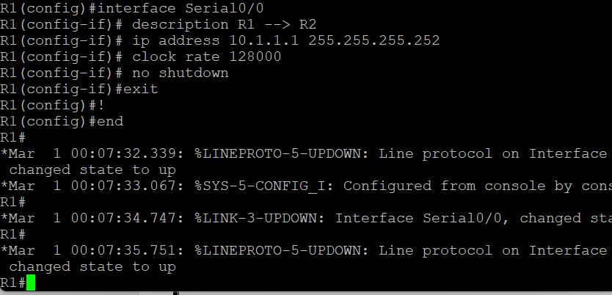

**R2**

hostname R2

!

interface Serial0/0

description R2 --> R1

ip address 10.1.1.2 255.255.255.252

no shutdown

exit

interface Serial0/1

description R2 --> R3

ip address 10.2.2.1 255.255.255.252

clock rate 128000

no shutdown

exit

!

End

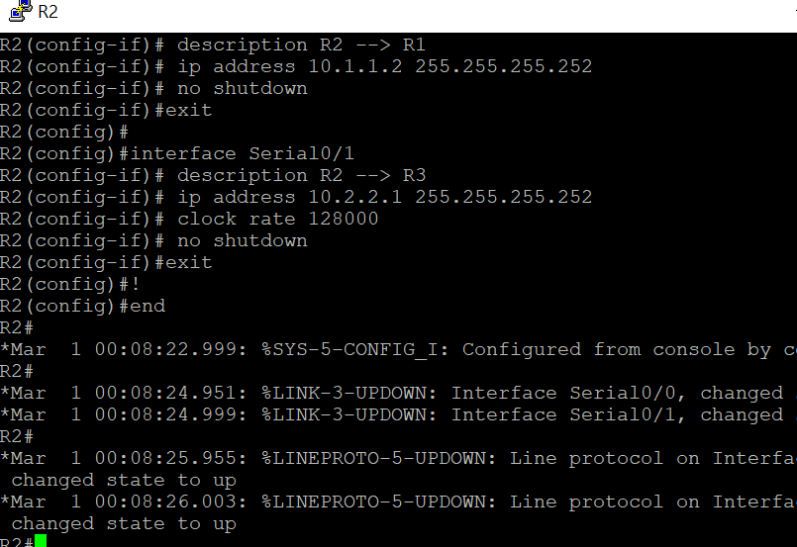

**R3**

hostname R3

!

interface Loopback0

description R3 LAN

ip address 192.168.3.1 255.255.255.0

exit

interface Serial0/1

description R3 --> R2

ip address 10.2.2.2 255.255.255.252

no shutdown

exit

!

End

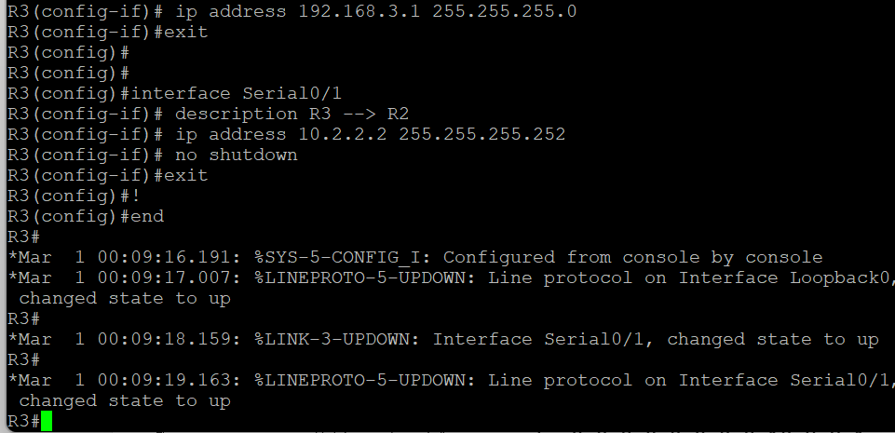

### **Step 2: Configure static routes.**

1. **On R1, configure a default static route to ISP.**

R1(config)# ip route 0.0.0.0 0.0.0.0 10.1.1.2

1. **On R3, configure a default static route to ISP.**

R3(config)# ip route 0.0.0.0 0.0.0.0 10.2.2.1

1. **On R2, configure two static routes.**

R2(config)# ip route 192.168.1.0 255.255.255.0 10.1.1.1

R2(config)# ip route 192.168.3.0 255.255.255.0 10.2.2.2

1. **From the R1 router, run the following Tcl script to verify connectivity.**

**R1# tclsh**

foreach address {

192.168.1.1

10.1.1.1

10.1.1.2

10.2.2.1

10.2.2.2

192.168.3.1

} { ping $address }

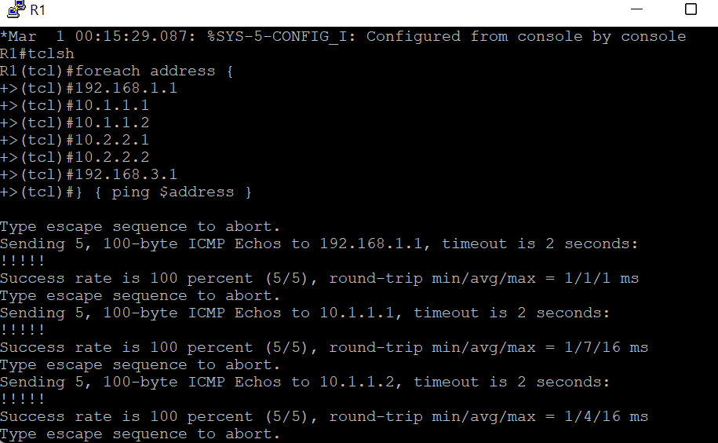

### **Step 3: Secure management access.**

1. **On R1, use the security passwords command to set a minimum password length of 10 characters.**

R1(config)# security passwords min-length 10

1. **Configure the enable secret encrypted password on both routers.**

R1(config)# enable secret class12345

1. **Configure a console password and enable login for routers. For additional security, the exec-timeout command causes the line to log out after 5 minutes of inactivity.**

R1(config)# **line console 0**

R1(config-line)# **password ciscoconpass**

R1(config-line)# **exec-timeout 5 0**

R1(config-line)# **login**

R1(config-line)# **logging synchronous**

R1(config-line)# **exit**

R1(config)#

1. **Configure the password on the vty lines for router R1.**

R1(config)# line vty 0 4

R1(config-line)# password ciscovtypass

R1(config-line)# exec-timeout 5 0

R1(config-line)# login

R1(config-line)# exit

R1(config)#

1. **The aux port is a legacy port used to manage a router remotely using a modem and is hardly ever used. Therefore, disable the aux port.**

R1(config)# **line aux 0**

R1(config-line)# **no exec**

R1(config-line)# **end**

R1#

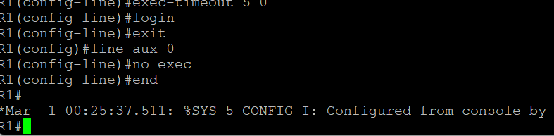

1. **Enter privileged EXEC mode and issue the** show run command**. Can you read the enable secret password? Why or why not?**

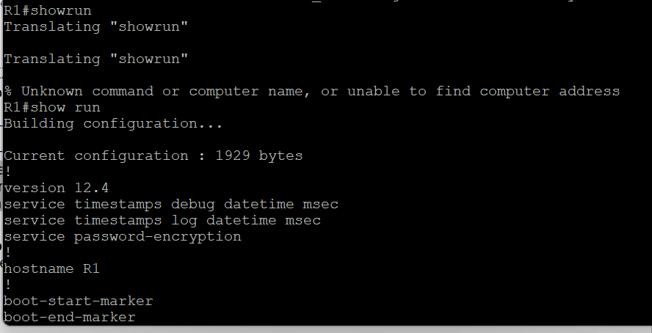

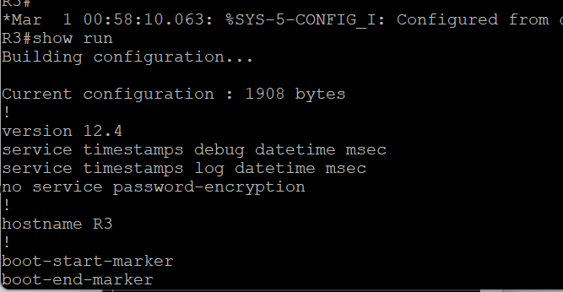

1. **Use the service password-encryption command to encrypt the line console and vty passwords.**

R1(config)# **service password-encryption**

R1(config)#

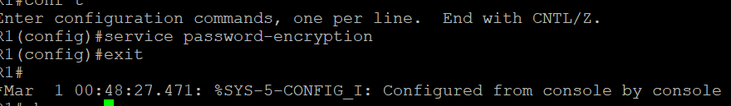

1. **Configure a warning to unauthorized users with a message-of-the-day (MOTD) banner using the banner motd command.**

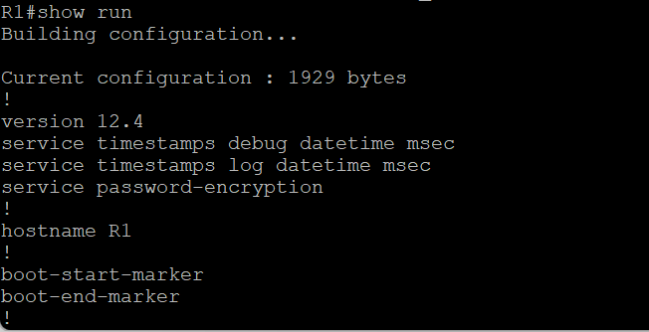

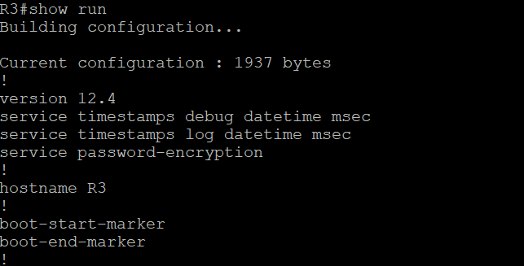

**i. Issue the show run command. Can you read the console, aux, and vty passwords.**

R1(config)# banner motd $Unauthorized access strictly prohibited!$

R1(config)# exit

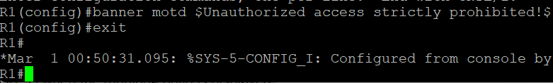

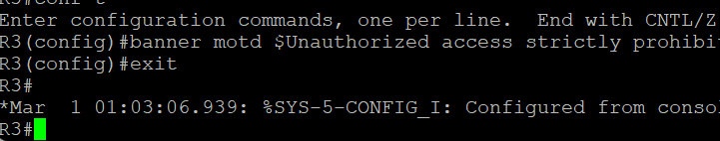

**j.Issue the show run command.**

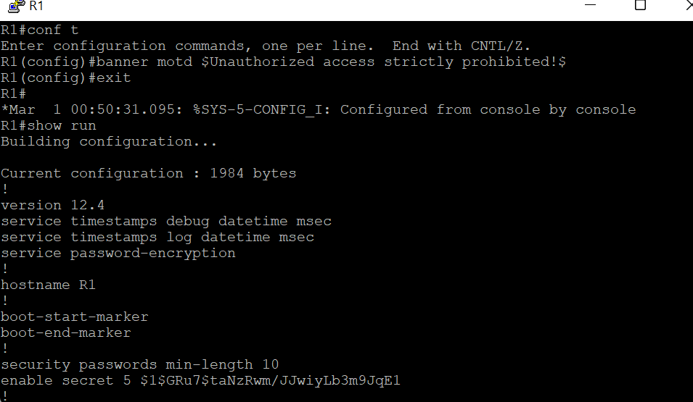

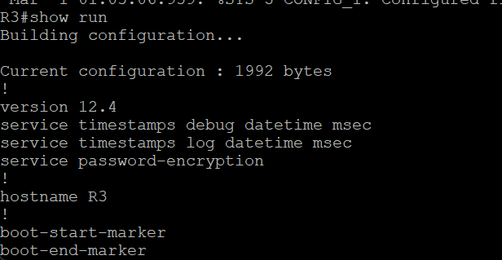

**k.Exit privileged EXEC mode using the disable or exit command and press Enter to get started.**

**l.** **Repeat the configuration portion of steps 3a through 3k on router R3**

### **Step 4: Configure enhanced username password security.**

1. **To create local database entry encrypted to level 4 (SHA256), use the username *name* secret *password* global configuration command. In global configuration mode, enter the following command:**

R1(config)# **username JR-ADMIN secret class12345**

R1(config)# **username ADMIN secret class54321**

1. **Set the console line to use the locally defined login accounts**.

R1(config)# **line console 0**

R1(config-line)# **login local**

R1(config-line)# **exit**

R1(config)#

1. **Set the vty lines to use the locally defined login accounts.**

R1(config)# **line vty 0 4**

R1(config-line)# **login local**

R1(config-line)# **end**

R1(config)#

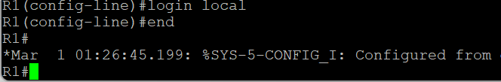

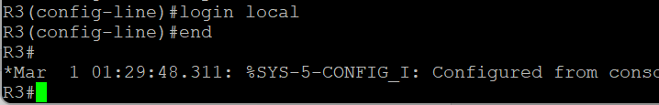

1. **Repeat the steps 4a to 4c on R3**.
2. **To verify the configuration, telnet to R3 from R1 and login using the ADMIN local database account.**

R1# **telnet 10.2.2.2**

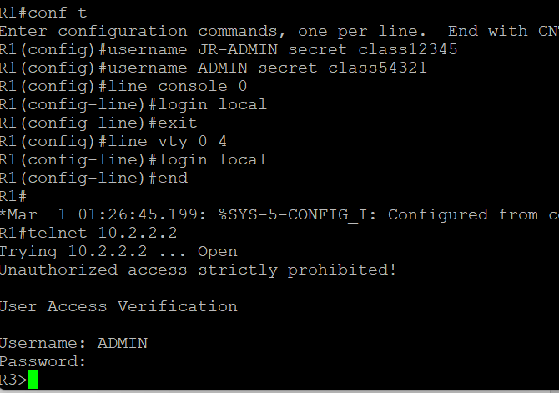

### **Step 5: Enabling secure remote management using SSH.**

1. **SSH requires that a device name and a domain name be configured. Since the router already has a name assigned, configure the domain name.**

R1(config)# **ip domain-name ccnasecurity.com**

1. **The router uses the RSA key pair for authentication and encryption of transmitted SSH data. Although optional it may be wise to erase any existing key pairs on the router.**

R1(config)# **crypto key zeroize rsa**

1. **Generate the RSA encryption key pair for the router. Configure the RSA keys with 1024 for the number of modulus bits**.

R1(config)# **crypto key generate rsa general-keys modulus 1024**

1. **Cisco routers support two versions of SSH:**

* **SSH version 1 (SSHv1)**: Original version but has known vulnerabilities.
* **SSH version 2 (SSHv2)**: Provides better security using the Diffie-Hellman key exchange and the strong integrity-checking message authentication code (MAC).

R1(config)# **ip ssh version 2**

R1(config)#

1. **Configure the vty lines to use only SSH connections.**

R1(config)# **line vty 0 4**

R1(config-line)# **transport input ssh**

R1(config-line)# **end**

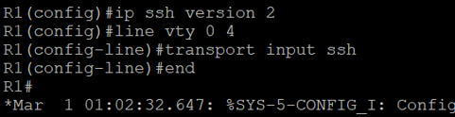

1. **Verify the SSH configuration using the show ip ssh command**.

R1# **show ip ssh**

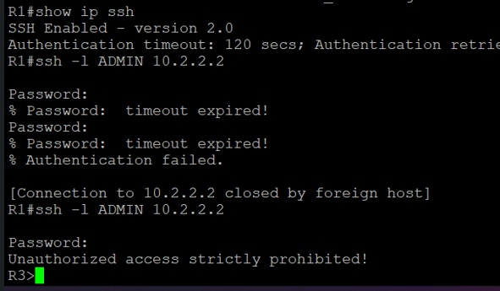

1. **Repeat the steps 6a to 6f on R3**.
2. **Although a user can SSH from a host using the SSH option of TeraTerm of PuTTY, a router can also SSH to another SSH enabled device. SSH to R3 from R1.**

R1# **ssh -l ADMIN 10.2.2.2**

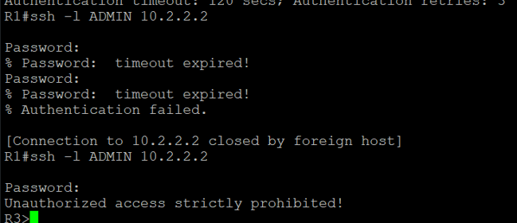

**Practical No – 5**

**Aim:** Configure and Verify Path Control Using PBR.

**Topolgy :**

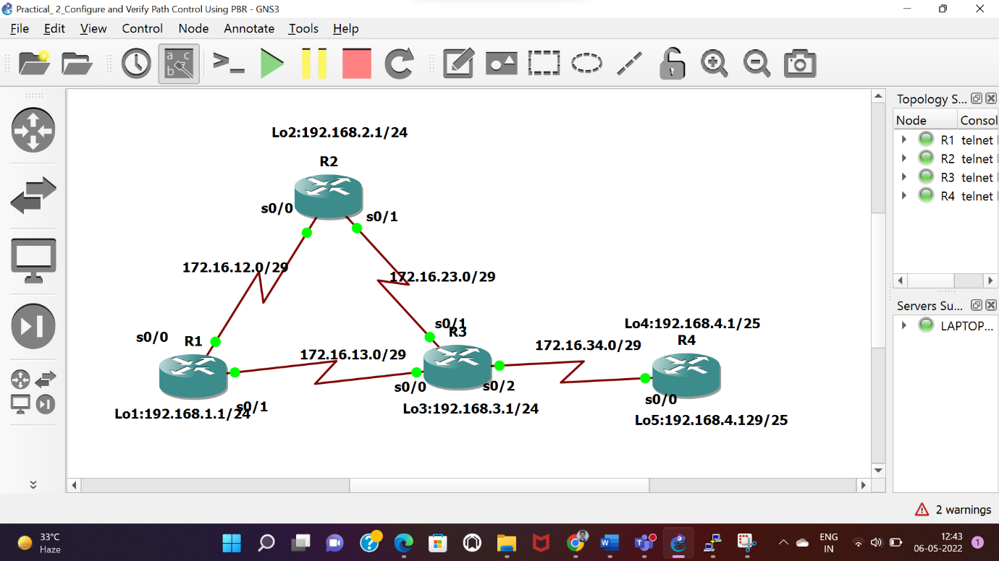

**Objectives**

* Configure and verify policy-based routing.
* Select the required tools and commands to configure policy-based routing operations.
* Verify the configuration and operation by using the proper show and debug commands.

**Required Resources**

* 4 routers (Cisco IOS Release 15.2 or comparable)
* Serial and Ethernet cables

**Step 1: Configure loopbacks and assign addresses.**

1. **Cable the network as shown in the topology diagram. Erase the startup configuration, and reload each router to clear previous configurations.**
2. **Using the addressing scheme in the diagram, create the loopback interfaces and apply IP addresses to these and the serial interfaces on R1, R2, R3, and R4.**

**Router R1**

hostname R1

!

interface Lo1

 description R1 LAN

 ip address 192.168.1.1 255.255.255.0

!

interface Serial0/0

 description R1 --> R2

 ip address 172.16.12.1 255.255.255.248

clock rate 128000

bandwidth 128

no shutdown

!

interface Serial0/1

 description R1 --> R3

ip address 172.16.13.1 255.255.255.248

bandwidth 64

no shutdown

!

End

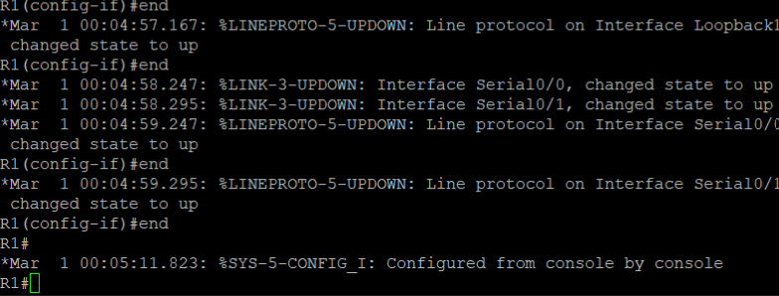

**Router R2**

hostname R2

!

interface Lo2

 description R2 LAN

 ip address 192.168.2.1 255.255.255.0

!

interface Serial0/0

 description R2 --> R1

 ip address 172.16.12.2 255.255.255.248

bandwidth 128

no shutdown

interface Serial0/1

 description R2 --> R3

 ip address 172.16.23.2 255.255.255.248

clock rate 128000

bandwidth 128

no shutdown

!

end

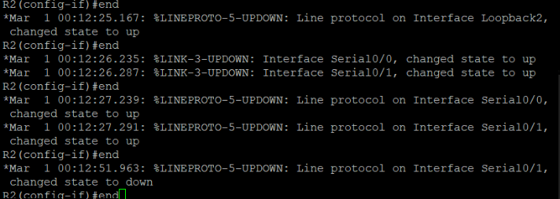

**Router R3**

hostname R3

!

interface Lo3

 description R3 LAN

 ip address 192.168.3.1 255.255.255.0

!

interface Serial0/0

 description R3 --> R1

 ip address 172.16.13.3 255.255.255.248

clock rate 64000

bandwidth 64

no shutdown

!

interface Serial0/1

 description R3 --> R2

ip address 172.16.23.3 255.255.255.248

bandwidth 128

no shutdown

!

interface Serial0/0

 description R3 --> R4

ip address 172.16.34.3 255.255.255.248

clock rate 64000

bandwidth 64

no shutdown

!

End

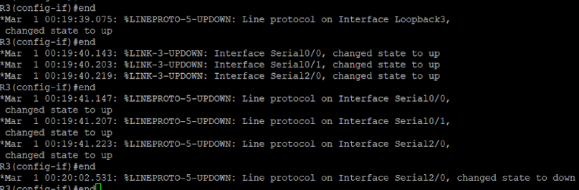

**Router R4**

hostname R4

!

interface Lo4

 description R4 LAN A

 ip address 192.168.4.1 255.255.255.128

!

interface Lo5

 description R4 LAN B

 ip address 192.168.4.129 255.255.255.128

!

interface Serial0/0

 description R4 --> R3

 ip address 172.16.34.4 255.255.255.248

bandwidth 64

no shutdown

!

End

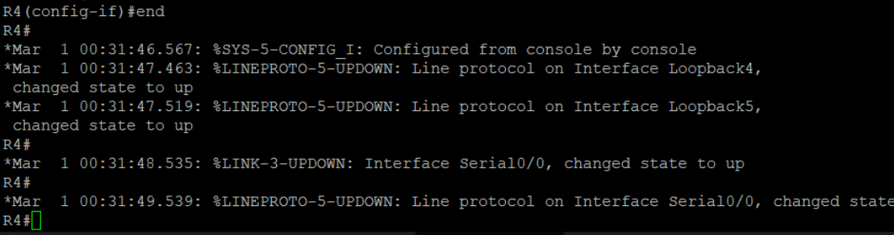

1. **Verify the configuration with the show ip interface brief, show protocols, and show interfaces description commands. The output from router R3 is shown here as an example**.

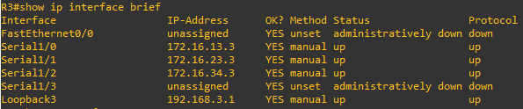R3# **show ip interface brief | include up**

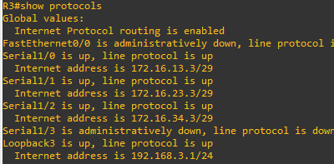R3# **show protocols**

R3# **show interfaces description | include up**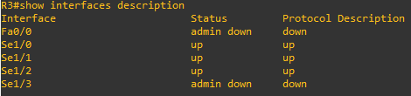

**Step 3: Configure basic EIGRP**

a. **Implement EIGRP AS 1 over the serial and loopback interfaces as you have configured it for the other EIGRP labs.**

b. **Advertise networks 172.16.12.0/29, 172.16.13.0/29, 172.16.23.0/29, 172.16.34.0/29, 192.168.1.0/24, 192.168.2.0/24, 192.168.3.0/24, and 192.168.4.0/24 from their respective routers**.

**Router R1**

router eigrp 1

network 192.168.1.0

 network 172.16.12.0 0.0.0.7

 network 172.16.13.0 0.0.0.7

no auto-summary

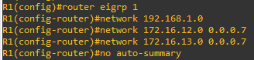

**Router R2**

router eigrp 1

network 192.168.2.0

 network 172.16.12.0 0.0.0.7

 network 172.16.23.0 0.0.0.7

no auto-summary

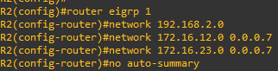

**Router R3**

router eigrp 1

network 192.168.3.0

 network 172.16.13.0 0.0.0.7

 network 172.16.23.0 0.0.0.7

 network 172.16.34.0 0.0.0.7

no auto-summary

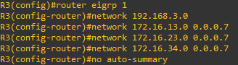

**Router R4**

router eigrp 1

network 192.168.4.0

 network 172.16.34.0 0.0.0.7

no auto-summary

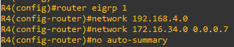

**Step 4: Verify EIGRP connectivity.**

1. **Verify the configuration by using the show ip eigrp neighbors command to check which routers have EIGRP adjacencies.**

R1# **show ip eigrp neighbors**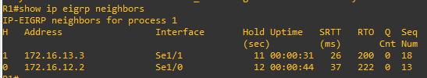

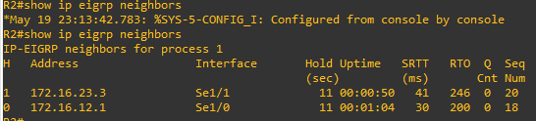R2# **show ip eigrp neighbors**

R3# **show ip eigrp neighbors**

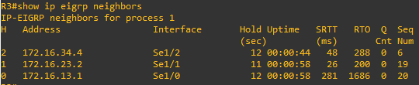

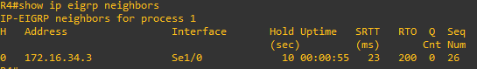R4# **show ip eigrp neighbors**

1. **Run the following Tcl script on all routers to verify full connectivity.**

R1# **tclsh**

**foreach address {**

**172.16.12.1**

**172.16.12.2**

**172.16.13.1**

**172.16.13.3**

**172.16.23.2**

**172.16.23.3**

**172.16.34.3**

**172.16.34.4**

**192.168.1.1**

**192.168.2.1**

**192.168.3.1**

**192.168.4.1**

**192.168.4.129**

**} { ping $address }**

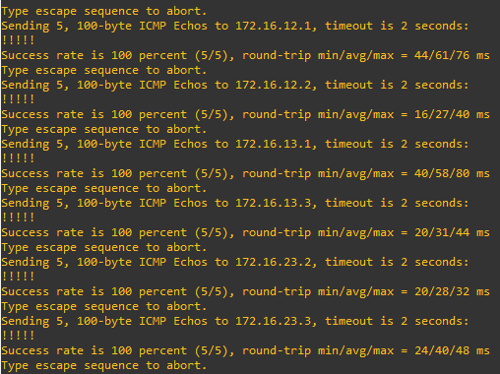

**Step 5: Verify the current path.**

1. **On R1, use the show ip route command. Notice the next-hop IP address for all networks discovered by EIGRP.**

R1# **show ip route | begin Gateway**

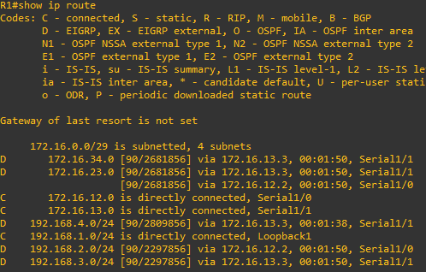

1. **On R4, use the traceroute command to the R1 LAN address and source the ICMP packet from R4 LAN A and LAN B.**

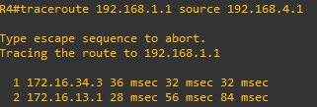R4# **traceroute 192.168.1.1 source 192.168.4.1**

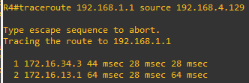R4# **traceroute 192.168.1.1 source 192.168.4.129**

1. **On R3, use the show ip route command and note that the preferred route from R3 to R1 LAN 192.168.1.0/24 is via R2 using the R3 exit interface S0/0/1.**

R3# **show ip route | begin Gateway**

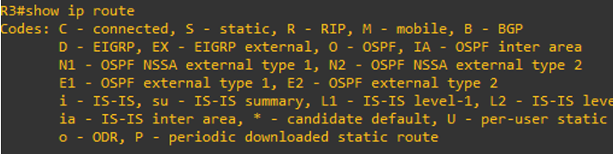

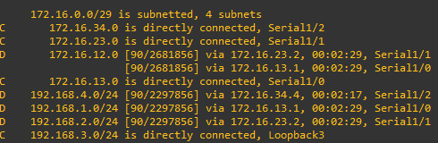

1. **On R3, use the show interfaces serial 0/0/0 and show interfaces s0/0/1 commands.**

R3# **show interfaces serial0/0**

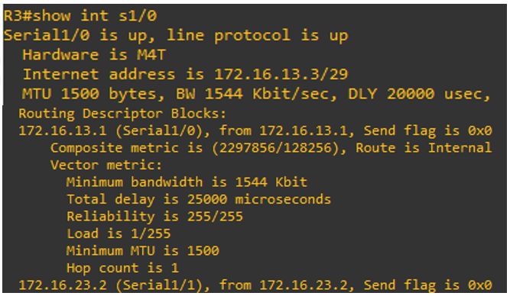

R3# **show interfaces serial0/0 | include BW**

R3# **show interfaces serial0/1 | include BW**

1. **Confirm that R3 has a valid route to reach R1 from its serial 0/0/0 interface using the show ip eigrp topology 192.168.1.0 command**.

R3# **show ip eigrp topology 192.168.1.0**

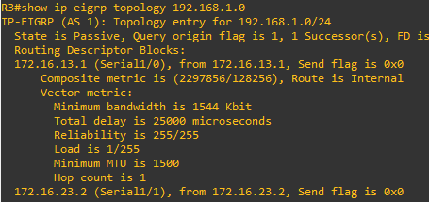

**Step 6: Configure PBR to provide path control.**

1. **On router R3, create a standard access list called PBR-ACL to identify the R4 LAN B network.**

R3(config)# **ip access-list standard PBR-ACL**

R3(config-std-nacl)# **remark ACL matches R4 LAN B traffic**

R3(config-std-nacl)# **permit 192.168.4.128 0.0.0.127**

R3(config-std-nacl)# **exit**

R3(config)#

1. **Create a route map called R3-to-R1 that matches PBR-ACL and sets the next-hop interface to the R1 serial 0/0/1 interface.**

R3(config)# **route-map R3-to-R1 permit**

R3(config-route-map)# **description RM to forward LAN B traffic to R1**

R3(config-route-map)# **match ip address PBR-ACL**

R3(config-route-map)# **set ip next-hop 172.16.13.1**

R3(config-route-map)# **exit**

R3(config)#

1. **Apply the R3-to-R1 route map to the serial interface on R3 that receives the traffic from R4. Use the ip policy route-map command on interface S0/1/0.**

R3(config)# **interface s0/0**

R3(config-if)# **ip policy route-map R3-to-R1**

R3(config-if)# **end**

R3#

1. **On R3, display the policy and matches using the show route-map command.**

**R3# show route-map**

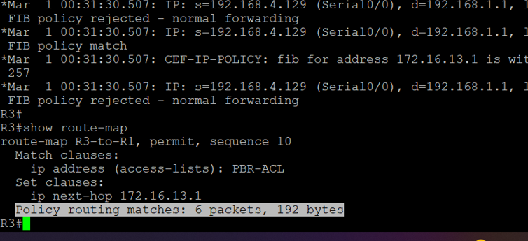

**Step 7: Test the policy.**

1. **On R3, create a standard ACL which identifies all of the R4 LANs**.

R3# **conf t**

Enter configuration commands, one per line. End with CNTL/Z.

R3(config)# **access-list 1 permit 192.168.4.0 0.0.0.255**

R3(config)# **exit**

1. **Enable PBR debugging only for traffic that matches the R4 LANs**.

R3# **debug ip policy ?**

R3# **debug ip policy 1**

1. **Test the policy from R4 with the traceroute command, using R4 LAN A as the source network.**

R4# **traceroute 192.168.1.1 source 192.168.4.1**

1. **Test the policy from R4 with the traceroute command, using R4 LAN B as the source network.**

R4# **traceroute 192.168.1.1 source 192.168.4.129**

1. **On R3, display the policy and matches using the show route-map command.**

R3# **show route-map**

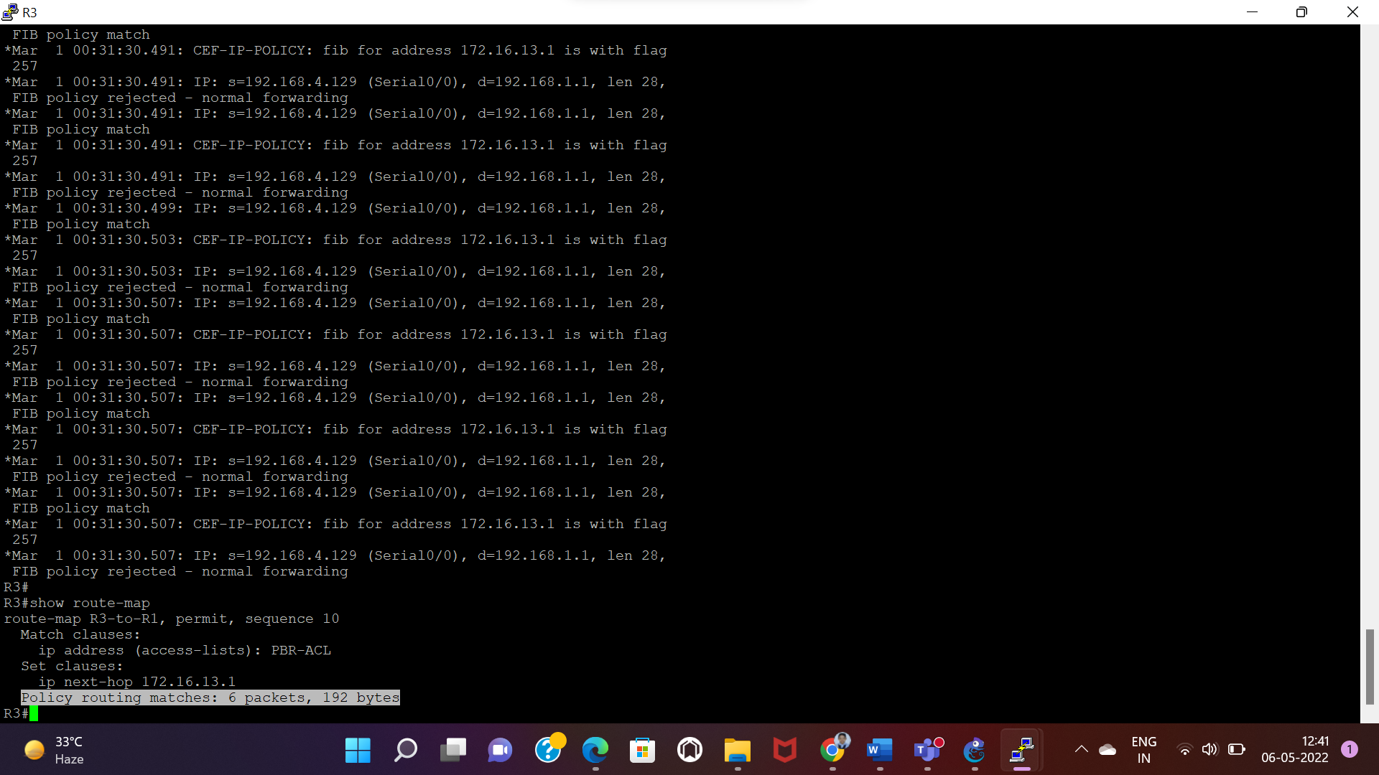

**Practical** **6**

**Aim**: Cisco MPLS Configuration.

**Topology**:

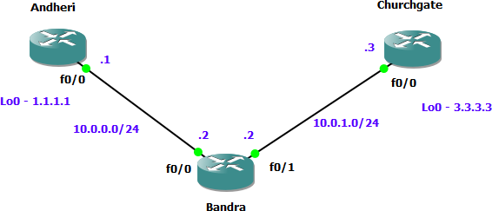

Step 1 *–* IP addressing of MPLS Core and OSPF

First bring 3 routers into your **Topology** R1, R2, R3 position them as below. We are going to address the routers and configure ospf to ensure loopback to loopback connectivity between R1 and R3

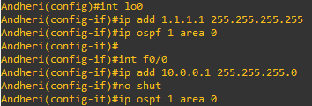

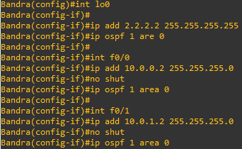

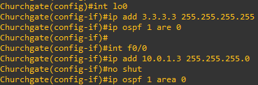

You should now have full ip connectivity between R1, R2, R3 to verify this we need to see if we can ping between the loopbacks of R1 and R3

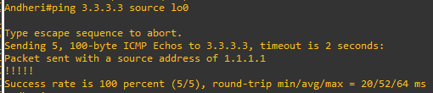

Step 2 *–* Configure LDP on all the interfaces in the MPLS Core

In order to run MPLS you need to enable it, there are two ways to do this.

At each interface enter the mpls ip command

Under the ospf process use the mpls ldp autoconfig command

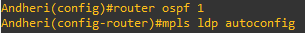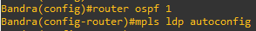

You should see log messages coming up showing the LDP neighbors are up.

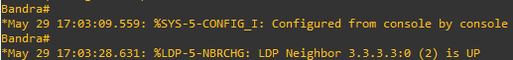

To verify the mpls interfaces the command is very simple – sh mpls interface

This is done on R2 and you can see that both interfaces are running mpls and using LDP

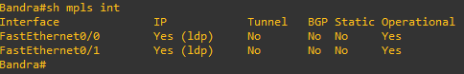

You can also verify the LDP neighbors with the sh mpls ldp neighbors command.

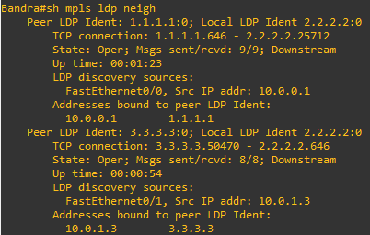

One more verification to confirm LDP is running ok is to do a trace between R1 and R3 and verify if you get MPLS Labels show up in the trace.

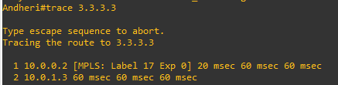

Step 3 *–* MPLS BGP Configuration between R1 and R3

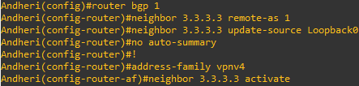We need to establish a Multi Protocol BGP session between R1 and R3 this is done by configuring the vpnv4 address family as below

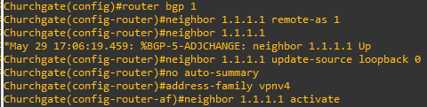

To verify the BGP session between R1 and R3 issue the command sh bgp vpnv4 unicast all summary

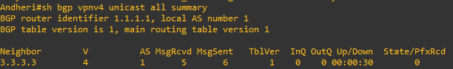

Step 4 *–* Add two more routers, create VRFs

We will add two more routers into the **Topology** so it now looks like the final **Topology**

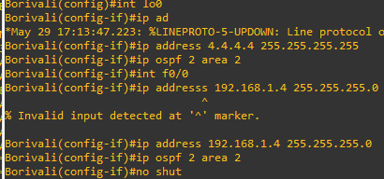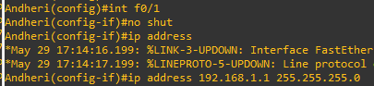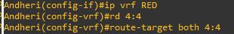

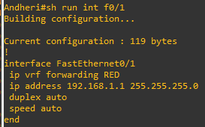

If you issue the command sh ip route this shows the routes in the global table and you will notice that you do not see 192.168.1.0/24

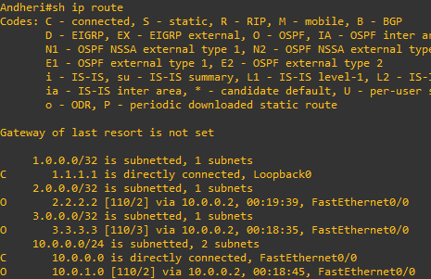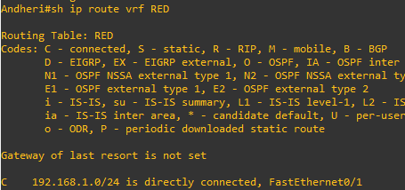

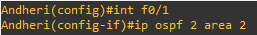We just need to enable OSPF on this interface and get the loopback address for R4 in the VRF RED routing table before proceeding.

If we now check the routes in the VRF RED routing table you should see 4.4.4.4 in there as well.

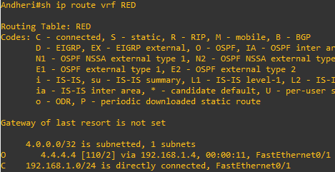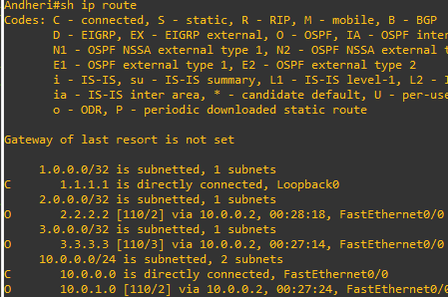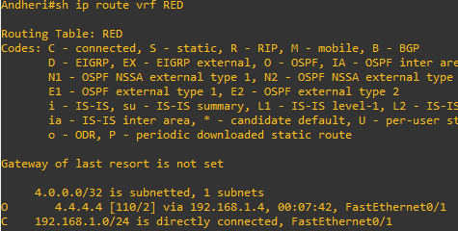

We now need to repeat this process for R3 & R6 Router 6 will peer OSPF using process number 2 to a VRF configured on R3. It will use the local site addressing to 192.168.2.0/24

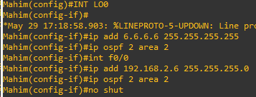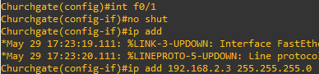

We also need to configure a VRF onto R3 as well.

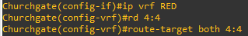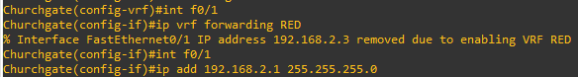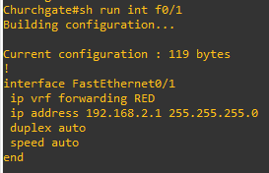

Check the router in vrf RED

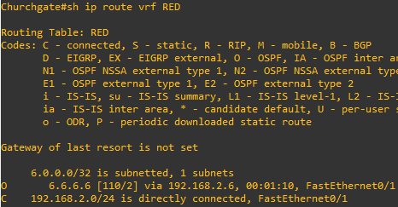

Ok so we have come a long way now let’s review the current situation. We now have this setup

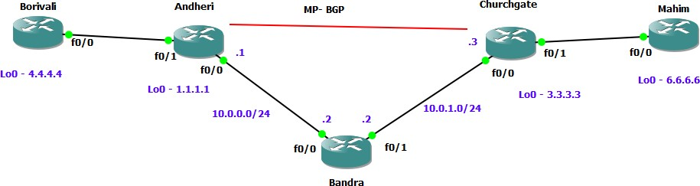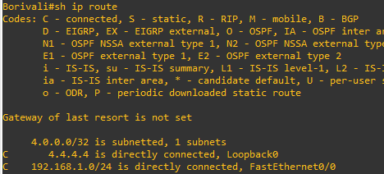

As expected we have the local interface and the loopback address. When we are done we want to see 6.6.6.6 in there so we can ping across the MPLS Check the routes on R1

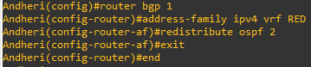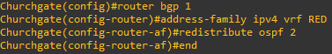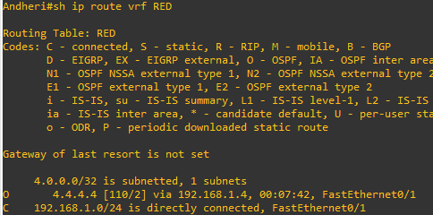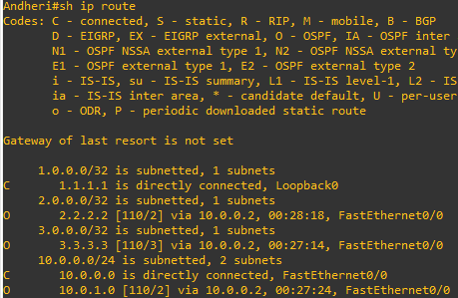

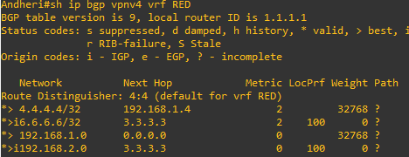

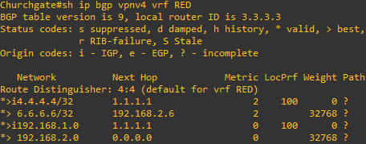

Which it is! 6.6.6.6 is now in the BGP table in VRF RED on R3 with a next hop of 192.168.2.6 (R6) and also 4.4.4 is in there as well with a next hop of 1.1.1.1 (which is the loopback of R1 – showing that it is going over the MPLS and R2 is not in the picture)



Before we do let’s see what the routing table look like on R4

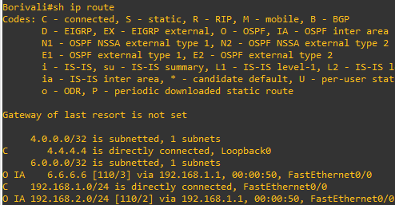

Do the same step of on R6

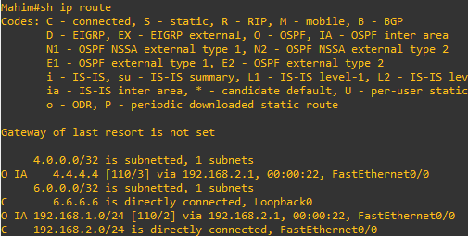

Lets chevk ping command

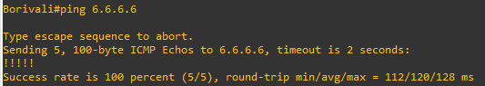

Which we can – to prove this is going over the mpls and be label switched and not routed, let do a trace

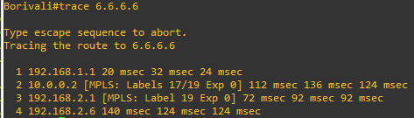

**Practical 7**

**Aim**: Inter-VLAN Routing

**Topology:**

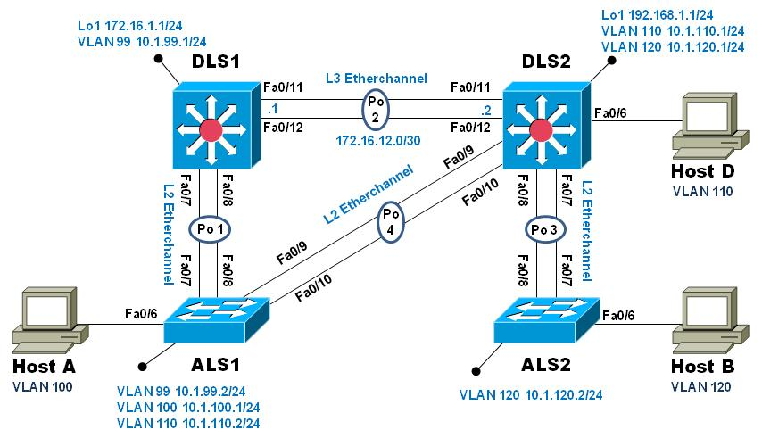

**Objectives**:

Implement a Layer 3 EtherChannel

Implement Static Routing

Implement Inter-VLAN Routing

Configure Multilayer Switching using Distribution Layer Switches

Load base config

Use the reset.tcl script you created in Lab 1 “Preparing the Switch” to set your switches up for this lab. Then load the file BASE.CFG into the running-config with the command **copy flash:BASE.CFG running-config**. An example from DLS1:

DLS1# **tclsh reset.tcl**

Erasing the nvram filesystem will remove all configuration files! Continue? [confirm]

[OK]

Erase of nvram: complete

Reloading the switch in 1 minute, type reload cancel to halt

Proceed with reload? [confirm]

*Mar 7 18:41:40.403: %SYS-7-NV_BLOCK_INIT: Initialized the geometry of nvram

*Mar 7 18:41:41.141: %SYS-5-RELOAD: Reload requested by console. Reload Reason: Reload command.

*<switch reloads - output omitted>*

Would you like to enter the initial configuration dialog? [yes/no]: n

Switch> **en**

*Mar 1 00:01:30.915: %LINK-5-CHANGED: Interface Vlan1, changed state to administratively down

Switch# **copy BASE.CFG running-config**

Destination filename [running-config]?

184 bytes copied in 0.310 secs (594 bytes/sec)

DLS1#

Verify switch management database configuration

At each switch, use the show sdm prefer command to verify the appropriate template is chosen. The DLS switches should be using the "dual ipv4-and-ipv6 routing" template and the ALS switches should be using the "lanbase-routing" template. If any of the switches are using the wrong template, make the necessary change and reboot the switch with the **reload** command. An example from ALS1 is below:

ALS1# **sho sdm pref**

The current template is "default" template.

<output omitted>

ALS1# **conf t**

Enter configuration commands, one per line. End with CNTL/Z.

ALS1(config)# **sdm pref lanbase-routing**

Changes to the running SDM preferences have been stored, but cannot take effect

until the next reload.

Use 'show sdm prefer' to see what SDM preference is currently active.

ALS1(config)# **end**

ALS1# **reload**

System configuration has been modified. Save? [yes/no]: **y**

*Mar 1 02:12:00.699: %SYS-5-CONFIG_I: Configured from console by console

Building configuration...

[OK]

Proceed with reload? [confirm]

Configure layer 3 interfaces on the DLS switches

Enable IP Routing, create broadcast domains (VLANs), and configure the DLS switches with the layer 3 interfaces and addresses shown:

|  |  |  |
| --- | --- | --- |
| Switch | Interface | Address/Mask |
| DLS1 | VLAN 99 | 10.1.99.1/24 |
| DLS1 | Loopback 1 | 172.16.1.1/24 |
| DLS2 | VLAN 110 | 10.1.110.1/24 |
| DLS2 | VLAN 120 | 10.1.120.1/24 |
| DLS2 | Loopback 1 | 192.168.2.1/24 |

An example from DLS2:

DLS2(config)# **ip routing**

DLS2(config)# **vlan 110**

DLS2(config-vlan)# **name Management**

DLS2(config-vlan)# **exit**

DLS2(config)# **vlan 120**

DLS2(config-vlan)# **name Local**

DLS2(config-vlan)# **exit**

DLS2(config)# **int vlan 110**

DLS2(config-if)# **ip address 10.1.110.1 255.255.255.0**

DLS2(config-if)# **no shut**

DLS2(config-if)# **exit**

DLS2(config)# **int vlan 120**

DLS2(config-if)# **ip address 10.1.120.1 255.255.255.0**

DLS2(config-if)# **no shut**

DLS2(config-if)# **exit**

DLS2(config)# **int loopback 1**

DLS2(config-if)# **ip address 192.168.1.1 255.255.255.0**

DLS2(config-if)# **no shut**

DLS2(config-if)# **exit**

DLS2(config)#

At this point, basic intervlan routing can be demonstrated using an attached host. Host D is attached to DLS2 via interface Fa0/6. On DLS2, assign interface Fa0/6 to VLAN 110 and configure the host with the address 10.1.110.50/24 and default gateway of 10.1.110.1. Once you have done that, try and ping Loopback 1’s IP address (192.168.1.1). This should work just like a hardware router; the switch will provide connectivity between two directly connected interfaces. In the output below, the **switchport host** macro was used to quickly configure interface Fa0/6 with host-relative commands:

DLS2(config)# **int f0/6**

DLS2(config-if)# **switchport host**

switchport mode will be set to access

spanning-tree portfast will be enabled

channel group will be disabled

DLS2(config-if)# **switchport access vlan 110**

DLS2(config-if)# **no shut**

DLS2(config-if)# **exit**

DLS2(config)#

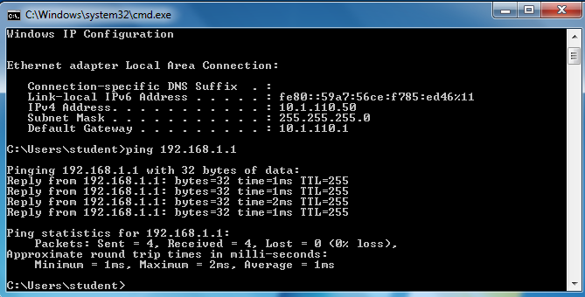

Configure a Layer 3 Etherchannel between DLS1 and DLS2

Now you will interconnect the multilayer switches in preparation to demonstrate other routing capabilities. Configure a layer 3 EtherChannel between the DLS switches. This will provide the benefit of increased available bandwidth between the two multilayer switches. To convert the links from layer 2 to layer 3, issue the **no switchport** command. Then, combine interfaces F0/11 and F0/12 into a single PAgP EtherChannel and then assign an IP address as shown.

|  |  |  |  |
| --- | --- | --- | --- |
| DLS1 | 172.16.12.1/30 | DLS2 | 172.16.12.2/30 |

Example from DLS1:

DLS1(config)# **interface range f0/11-12**

DLS1(config-if-range)# **no switchport**

DLS1(config-if-range)# **channel-group 2 mode desirable**

Creating a port-channel interface Port-channel 2

DLS1(config-if-range)# **no shut**

DLS1(config-if-range)# **exit**

DLS1(config)# **interface port-channel 2**

DLS1(config-if)# **ip** **address 172.16.12.1 255.255.255.252**

DLS1(config-if)# **no shut**

DLS1(config-if)# **exit**

DLS1(config)#

Once you have configured both sides, verify that the EtherChannel link is up

DLS2# **show etherchannel summary**

Flags: D - down P - bundled in port-channel

I - stand-alone s - suspended

H - Hot-standby (LACP only)

R - Layer3 S - Layer2

U - in use f - failed to allocate aggregator

M - not in use, minimum links not met

u - unsuitable for bundling

w - waiting to be aggregated

d - default port

Number of channel-groups in use: 1

Number of aggregators: 1

Group Port-channel Protocol Ports

------+-------------+-----------+-----------------------------------------------

2 Po2(RU) PAgP Fa0/11(P) Fa0/12(P)

DLS2# **ping 172.16.12.1**

Type escape sequence to abort.

Sending 5, 100-byte ICMP Echos to 172.16.12.1, timeout is 2 seconds:

.!!!!

Success rate is 80 percent (4/5), round-trip min/avg/max = 1/3/9 ms

DLS2#

Configure default routing between DLS switches

At this point, local routing is support at each distribution layer switch. Now to provide reachability across the layer 3 EtherChannel trunk, configure fully qualified static default routes at DLS1 and DLS2 that point to each other. From DLS1:

DLS1(config)# **ip route 0.0.0.0 0.0.0.0 port-channel 2**

**%Default route without gateway, if not a point-to-point interface, may impact performance**

DLS1(config)# **ip route 0.0.0.0 0.0.0.0 port-channel 2 172.16.12.2**

DLS1(config)#

Once done at both ends, verify connectivity by pinging from one switch to the other. In the example below, DLS2 pings the Loopback 1 interface at DLS1.

DLS2# **show ip route**

Codes: L - local, C - connected, S - static, R - RIP, M - mobile, B - BGP

<output omitted>

Gateway of last resort is 172.16.12.1 to network 0.0.0.0

S* 0.0.0.0/0 [1/0] via 172.16.12.1, Port-channel2

10.0.0.0/8 is variably subnetted, 2 subnets, 2 masks

C 10.1.110.0/24 is directly connected, Vlan110

L 10.1.110.1/32 is directly connected, Vlan110

172.16.0.0/16 is variably subnetted, 2 subnets, 2 masks

C 172.16.12.0/30 is directly connected, Port-channel2

L 172.16.12.2/32 is directly connected, Port-channel2

192.168.1.0/24 is variably subnetted, 2 subnets, 2 masks

C 192.168.1.0/24 is directly connected, Loopback1

L 192.168.1.1/32 is directly connected, Loopback1

DLS2# **ping 172.16.1.1**

Type escape sequence to abort.

Sending 5, 100-byte ICMP Echos to 172.16.1.1, timeout is 2 seconds:

!!!!!

Success rate is 100 percent (5/5), round-trip min/avg/max = 1/4/9 ms

DLS2#

Configure the remaining EtherChannels for the topology

Configure the remaining EtherChannel links as layer 2 PagP trunks using VLAN 1 as the native VLAN.

|  |  |  |  |
| --- | --- | --- | --- |
| Endpoint 1 | Channel number | Endpoint 2 | VLANs Allowed |
| ALS1 F0/7-8 | 1 | DLS1 F0/7-8 | All except 110 |
| ALS1 F0/9-10 | 4 | DLS2 F0/9-10 | 110 Only |
| ALS2 F0/7-8 | 3 | DLS2 F0/7-8 | All |

Example from ALS1:

ALS1(config)# **interface range f0/7-8**

ALS1(config-if-range)# **switchport mode trunk**

ALS1(config-if-range)# **switchport trunk allowed vlan except 110**

ALS1(config-if-range)# **channel-group 1 mode desirable**

Creating a port-channel interface Port-channel 1

ALS1(config-if-range)# **no shut**

ALS1(config-if-range)# **exit**

ALS1(config)# **interface range f0/9-10**

ALS1(config-if-range)# **switchport mode trunk**

ALS1(config-if-range)# **switchport trunk allowed vlan 110**

ALS1(config-if-range)# **channel-group 4 mode desirable**

Creating a port-channel interface Port-channel 4

ALS1(config-if-range)# **no shut**

ALS1(config-if-range)# **exit**

ALS1(config)#end

ALS1# **show etherchannel summary**

Flags: D - down P - bundled in port-channel

I - stand-alone s - suspended

H - Hot-standby (LACP only)

R - Layer3 S - Layer2

U - in use f - failed to allocate aggregator

M - not in use, minimum links not met

u - unsuitable for bundling

w - waiting to be aggregated

d - default port

Number of channel-groups in use: 2

Number of aggregators: 2

Group Port-channel Protocol Ports

------+-------------+-----------+-----------------------------------------------

1 Po1(SU) PAgP Fa0/7(P) Fa0/8(P)

4 Po4(SU) PAgP Fa0/9(P) Fa0/10(P)

ALS1# **show interface trunk**

Port Mode Encapsulation Status Native vlan

Po1 on 802.1q trunking 1

Po4 on 802.1q trunking 1

Port Vlans allowed on trunk

Po1 1-109,111-4094

Po4 110

<output omitted>

ALS1#

Enable and Verify Layer 3 connectivity across the network

In this step we will enable basic connectivity from the management VLANs on both sides of the network.

Create the management VLANs (99 at ALS1, 120 at ALS2)

Configure interface VLAN 99 at ALS1 and interface VLAN 120 at ALS2

Assign addresses (refer to the diagram) and default gateways (at DLS1/DLS2 respectively).

Once that is all done, pings across the network should work, flowing across the layer 3 EtherChannel. An example from ALS2:

ALS2(config)# **vlan 120**

ALS2(config-vlan)# **name Management**

ALS2(config-vlan)# **exit**

ALS2(config)# **int vlan 120**

ALS2(config-if)# **ip address 10.1.120.2 255.255.255.0**

ALS2(config-if)# **no shut**

ALS2(config-if)# **exit**

ALS2(config)# **ip default-gateway 10.1.120.1**

ALS2(config)# **end**

ALS2# **ping 10.1.99.2**

Type escape sequence to abort.

Sending 5, 100-byte ICMP Echos to 10.1.99.2, timeout is 2 seconds:

..!!!

Success rate is 60 percent (3/5), round-trip min/avg/max = 1/3/8 ms

ALS2#

ALS2# **traceroute 10.1.99.2**

Type escape sequence to abort.

Tracing the route to 10.1.99.2

VRF info: (vrf in name/id, vrf out name/id)

1 10.1.120.1 0 msec 0 msec 8 msec

2 172.16.12.1 0 msec 0 msec 8 msec

3 10.1.99.2 0 msec 0 msec *

ALS2#

Configure Multilayer Switching at ALS1

At this point all routing is going through the DLS switches, and the port channel between ALS1 and DLS2 is not passing anything but control traffic (BPDUs, etc).

The Cisco 2960 is able to support basic routing when it is using the LANBASE IOS. In this step you will configure ALS1 to support multiple SVIs and configure it for basic static routing. The objectives of this step are:

Enable intervlan routing between two VLANs locally at ALS1

Enable IP Routing

Configure a static route for DLS2's Lo1 network travel via Port-Channel 4.

Configure additional VLANs and VLAN interfaces

At ALS1, create VLAN 100 and VLAN 110 and then create SVIs for those VLANs:

ALS1(config)# **ip routing**

ALS1(config)# **vlan 100**

ALS1(config-vlan)# **name Local**

ALS1(config-vlan)# **exit**

ALS1(config)# **vlan 110**

ALS1(config-vlan)# **name InterNode**

ALS1(config-vlan)# **exit**

ALS1(config)# **int vlan 100**

ALS1(config-if)# **ip address 10.1.100.1 255.255.255.0**

ALS1(config-if)# **no shut**

ALS1(config-if)# **exit**

ALS1(config)# **int vlan 110**

ALS1(config-if)# **ip address 10.1.110.2 255.255.255.0**

ALS1(config-if)# **no shut**

ALS1(config-if)# **exit**

ALS1(config)#

Configure and test Host Access

Assign interface Fa0/6 to VLAN 100. On the attached host (Host A) configure the IP address 10.1.100.50/24 with a default gateway of 10.1.100.1. Once configured, try a traceroute from the host to 10.1.99.2 and observe the results.

In the output below, the **switchport host** macro was used to quickly configure interface Fa0/6 with host-relative commands.

ALS1(config)# **interface f0/6**

ALS1(config-if)# **switchport host**

switchport mode will be set to access

spanning-tree portfast will be enabled

channel group will be disabled

ALS1(config-if)# **switchport access vlan 100**

ALS1(config-if)# **no shut**

ALS1(config-if)# **exit**

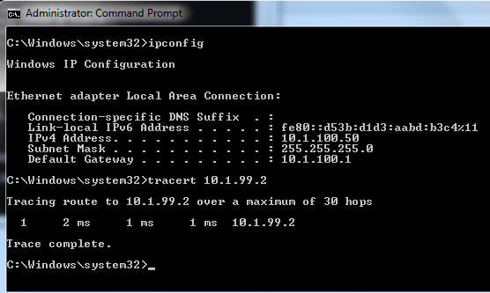

The output from the host shows that attempts to communicate with interface VLAN 99 at ALS1 were fulfilled locally, and not sent to DLS1 for routing.

Configure and verify static routing across the network

At this point, local routing (at ALS1) works, and off-net routing (outside of ALS1) will not work, because DLS1 doesn't have any knowledge of the 10.1.100.0 subnet. In this step you will configure routing on several different switches:

At DLS1, configure:

a static route to the 10.1.100.0/24 network via VLAN 99

At DLS2, configure

a static route to the 10.1.100.0/24 network via VLAN 110

At ALS1, configure

a static route to the 192.168.1.0/24 network via VLAN 110

a default static route to use 10.1.99.1

Here is an example from ALS1:

ALS1(config)# **ip route 192.168.1.0 255.255.255.0 vlan 110**

ALS1(config)# **ip route 0.0.0.0 0.0.0.0 10.1.99.1**

ALS1(config)# **end**

ALS1# **show ip route**

Codes: L - local, C - connected, S - static, R - RIP, M - mobile, B - BGP

D - EIGRP, EX - EIGRP external, O - OSPF, IA - OSPF inter area

N1 - OSPF NSSA external type 1, N2 - OSPF NSSA external type 2

E1 - OSPF external type 1, E2 - OSPF external type 2

i - IS-IS, su - IS-IS summary, L1 - IS-IS level-1, L2 - IS-IS level-2

ia - IS-IS inter area, * - candidate default, U - per-user static route

o - ODR, P - periodic downloaded static route, H - NHRP, l - LISP

+ - replicated route, % - next hop override

Gateway of last resort is 10.1.99.1 to network 0.0.0.0

S* 0.0.0.0/0 [1/0] via 10.1.99.1

10.0.0.0/8 is variably subnetted, 6 subnets, 2 masks

C 10.1.99.0/24 is directly connected, Vlan99

L 10.1.99.2/32 is directly connected, Vlan99

C 10.1.100.0/24 is directly connected, Vlan100

L 10.1.100.1/32 is directly connected, Vlan100

C 10.1.110.0/24 is directly connected, Vlan110

L 10.1.110.2/32 is directly connected, Vlan110

S 192.168.1.0/24 is directly connected, Vlan110

After configuring all of the required routes, test to see that the network behaves as expected.

From ALS1, a traceroute to 10.1.120.2 should take three hops:

ALS1# **traceroute 10.1.120.2**

Type escape sequence to abort.

Tracing the route to 10.1.120.2

VRF info: (vrf in name/id, vrf out name/id)

1 10.1.99.1 0 msec 0 msec 0 msec

2 172.16.12.2 9 msec 0 msec 0 msec

3 10.1.120.2 0 msec 8 msec *

ALS1#

From ALS1, a traceroute to 192.168.1.1 should take one hop:

ALS1# **traceroute 192.168.1.1**

Type escape sequence to abort.

Tracing the route to 192.168.1.1

VRF info: (vrf in name/id, vrf out name/id)

1 10.1.110.1 0 msec 0 msec *

ALS1#

Traces from Host A show an additional hop, but follow the appointed path:

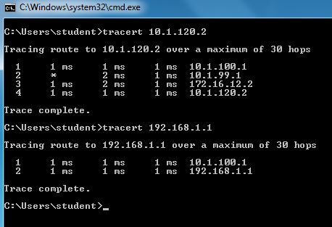

End of Lab

Save your configurations. The switches will be used as configured now for lab 5-2, DHCP.